IN THE MATTER of the Resource Management Act 1991 (RMA)
AND
IN THE MATTER of Private Plan Change 51 – Karaka and Drury Limited - land generally bounded by Drury Creek to the east, Future Urban Zoned land to the west and Karaka Road/State Highway 22 to the south and south east (Drury West) to the Auckland Unitary Plan – Operative in Part.

DIRECTIONS FROM THE HEARING PANEL

EXCUSING MR LANDERS FROM THE HEARING.

- Pursuant to section 34 and 34A of the RMA, Auckland Council (the Council) has appointed a Hearing Panel consisting of independent hearing commissioners - Greg Hill (Chairperson), Mark Farnsworth and Karyn Kurzeja. The Hearing Panel’s function is to hear the application and submissions and make a decision on the Plan Change proposal. It is also to address any procedural issues.

- The hearing of this Plan Change has been scheduled for 4, 5, 8, 9 and 11 November 2021.

- The Hearing Panel has read the Application (and all associated material), the Section 42A report, the expert evidence of the Applicant and Submitters. Having read that evidence, the Hearing Panel, at this stage, does not have questions for Mr Landers with respect to geotechnical matters. Accordingly, pursuant to section 41C of the RMA we excuse Mr Landers from presenting his evidence at the hearing.

- Notwithstanding the above, if any questions arise for Mr Landers during the course of the hearing, the Hearing Panel will either provide written questions to him, or if necessary call him the hearing (either in person, by phone or on-line).

- Any enquiries regarding this Direction or related matters should be directed to the Council’s Senior Hearings Advisor, Mr Sam Otter by email at sam.otter@aucklandcouncil.govt.nz.
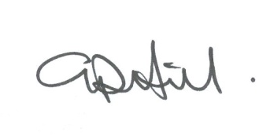

Greg Hill Chairperson
29 October 2021

