Te Mahere ā-Tau 2026/2027 Te Tuhinga Whiriwhiri Kōrero

Annual Plan 2026/2027 Consultation Document

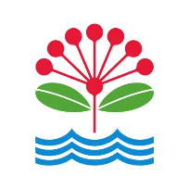

Mihi
Mai te Kore i takea mai te Ao, taka iho rā.
Ko Māui Tiki a Taranga, ko Tāwhakinui ā Hema.
Ko te Kāhui Tupua, ko te Kāhui Maunga.
Kia puta ake ko Maru-ā-Iwi, ko Te Tini o Toi.
Horapangia ana te iwi, taurihia katoatia te whenua.
He whenua taurikura, he whenua parekura.
He whenua whai rawa, he whenua tapu.
He kōpu whenua, he whenua makaurau.
“Ko wai te whenua e kōrerohia ake nei e.i?”
“Ko Tāmaki Herenga Waka,
Ko Tāmaki Herenga Tāngata,
Ko Tāmaki Herenga Wawata,
Ko Tāmaki Herenga Taonga.”
“Mō wai te whenua e manaaki ake nei e.i?”
“ Mō te iti, mō te rahi, Mō te kotahi, mō te katoa, Mō tātou, mō te iwi!”
Tihei winiwini, Tihei wanawana, Tihei Tāmaki Makaurau e…i!
Haumi ē! Hui ē! Tāiki ē!
From the void came the world, descending into being.
Māui the innovator, Tāwhaki the seeker of knowledge.
The sacred assembly of ancestors, the steadfast mountains.
From these, the multitudes of iwi emerged, spreading across the land.
A land of abundance, a land of conflict.
A land rich in resources, a land sacred and revered.
A fertile land, a land desired by many.
“Which land do we speak of?”
“Tāmaki – the mooring place of canoes,
Tāmaki – the mooring place of people,
Tāmaki – the mooring place of aspirations,
Tāmaki – the mooring place of treasures”
“For whom does this land offer its care?”
“ For the small and the great, For one and for all, For all of us, for the people.”
Behold the thrill, behold the awe, behold Tāmaki Makaurau!
Join together, unite as one!
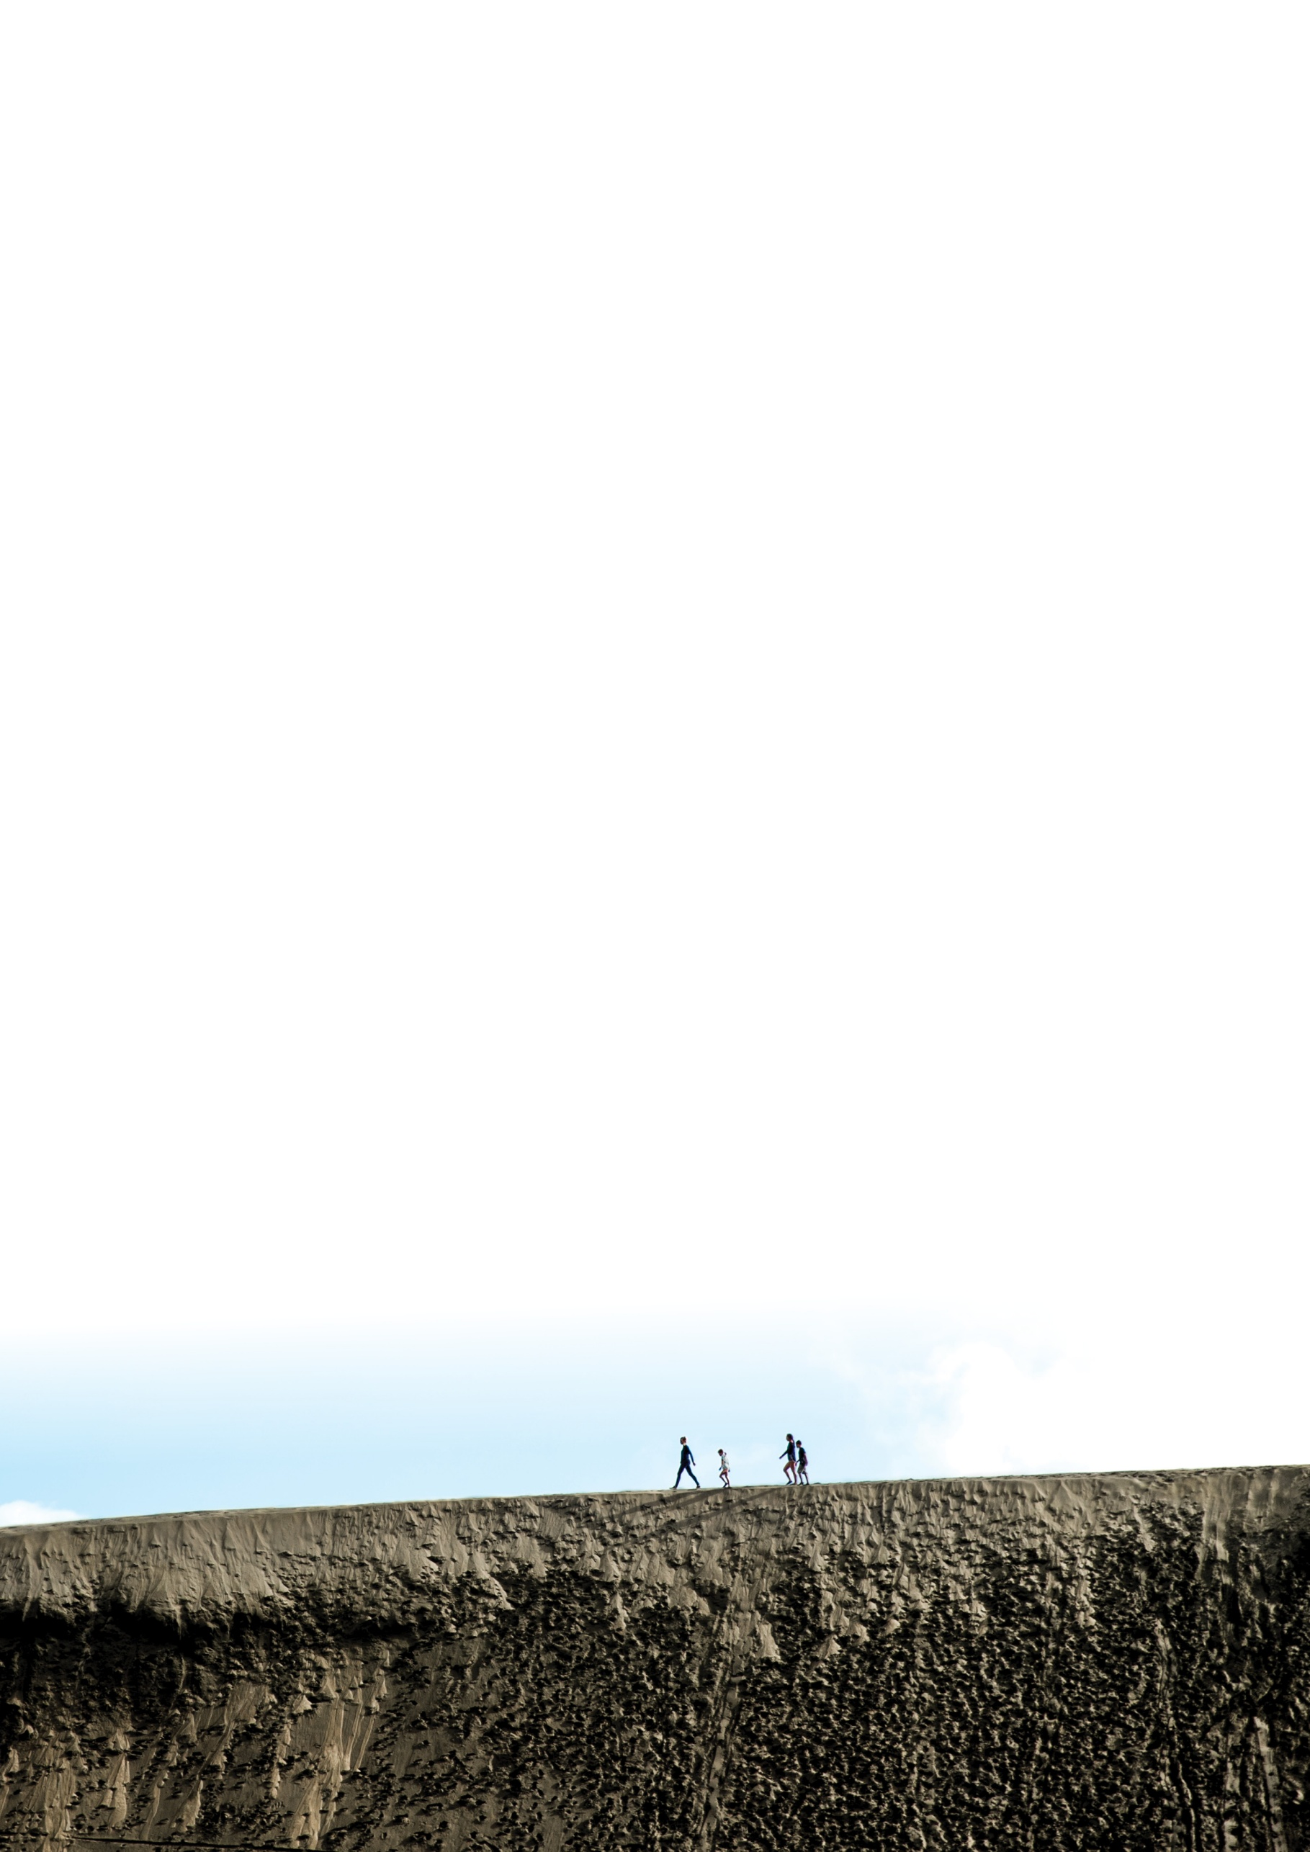
On the cover: Martins Bay Holiday Park | On this page: Te Henga sand dunes
Rārangi kōrero

Contents
Annual Plan 2026/2027 Consultation Document
Part 1
Tirohanga Whānui
Overview – page 4
Part 2
Ngā poari ā-rohe
Local boards – page 19
Part 3
Ō reiti me ētahi atu tūemi
Your rates and other items – page 45
Part 4
He ara hei whakaputa i ō kōrero
Have your say – page 51
Part 1
Tirohanga Whānui

Overview

About this document
This document sets out our plans for Auckland for the coming year. It aims to give Aucklanders the information they need to have a say in the decisions we make.
Our proposed annual plan for 2026/2027 represents and builds on our plans for the third year of our Long-term Plan 2024-2034 (LTP).
This document outlines what we want your feedback on including:
- what we plan to spend money on
- the services we plan to provide
- areas where our plans have changed from those in the LTP.
This consultation document is based on the best information currently available. At the time of writing this document, our financial forecasts are not materially different from those set out in our LTP. However, there are risks that could change this.

Have Your Say on our Annual Plan 2026/2027
We want to hear from all communities, so there are a number of ways you can find out more and have your say. These include written and online feedback forms, face-to-face events, phone, social media and webinar options.
There are also translated summaries of this document, including the feedback form, available in: Te Reo Māori, Korean, Samoan, Tongan, Simplified and Traditional Chinese, and Hindi.
New Zealand Sign Language videos and EasyRead documents are also available on akhaveyoursay.nz/ourplan.
The feedback form is on pages 54-58.
You can give us your feedback until 11.59 PM on Sunday 29 March 2026.
For further information, including supporting information for this consultation document, you can:
- visit akhaveyoursay/ourplan
- phone 09 301 0101
- visit your library.
The council will make final decisions for the Annual Plan 2026/2027 on 30 June 2026. The final plan will be available on aucklandcouncil.govt.nz in July 2026.

Consultation timeline

Public consultation
27 February — 29 March 2026
This is when you can have your say.
Deliberations
The Governing Body and local boards will consider public feedback.
Adoption of Annual Plan 2026/2027
By 30 June 2026
Governing Body adopts the final Annual Plan 2026/2027.

Message from the mayor
This annual plan sticks to what we agreed through our Long-term Plan 2024-2034. We said we would fix Auckland by being disciplined with money, finishing what we started, and getting better value from every dollar. That approach is working, so we are staying the course.
For 2026/2027, the council will invest $3.9 billion in the infrastructure Auckland needs and spend around $5.3 billion on the services people rely on. To fund this, we will keep debt at prudent levels and deliver a $106 million savings target. The average residential rates increase is 7.9 per cent, driven by the cost of opening and operating the City Rail Link (CRL). It’s a big bill, but once CRL is running it will help transform how we move around the city and support economic growth. This benefits the whole public transport network not just in the city centre.
This rates increase was signalled in our long-term plan, and I would like to explain the drivers behind it. The annual operating cost for CRL is projected to be $235 million (Auckland Transport operating cost for services and stations $26 million, interest $167 million and depreciation funding $42 million). This is the same amount as is delivered by the 7.9% rates increase which means the savings I am driving throughout the council, along with growth in our rating base, are offsetting underlying cost pressures from inflation and growth in services.
No-one likes cost increases. They are hard on our community, and my expectation is that we do everything to keep working on bringing our costs down to avoid further burden on ratepayers, while providing appropriate and accessible support for those experiencing financial hardship.
This budget is about continuing to do things better, faster, cheaper to minimise the impact on ratepayers. We are lifting performance across the council and I’m doing my best to stop the dumb stuff that wastes time and money. The Better Value Projects programme and the ten spending rules are now standard practice, and we are seeing the benefits. My expectation is simple: deliver smarter services, maintain what we have, and get more from every asset. Under the leadership of my Deputy Mayor, we have a Value for Money Committee who is setting ambitious savings targets so we can achieve lower rates increases in future years.
A major focus for the coming year is transport reform. After years of frustration, we are finally taking back control of transport in Auckland. The Government’s reform legislation is moving, and we need to be ready. Auckland Transport will become a public transport service provider only, with the rest brought into the council so decisions are simpler, faster, making us more accountable. Transport planning must sit alongside land-use planning, and delivery must be practical, cost-effective, and focused on the whole network, not silos. We need to eliminate doing things that have annoyed Aucklanders for too long.
We are also progressing the next phase of CCO reform, including a more commercial approach to urban regeneration, better property management, and stronger economic development. Auckland’s city centre is critical to our region’s success, contributing a significant share of our GDP. We will continue working with Government to improve safety, activate public spaces, and support a busier, more productive centre including more simple, effective ideas like Browny’s Pool.
Most importantly, this plan reflects our agreement with Aucklanders. It maintains financial discipline, keeps investment flowing into essential services, and prepares us for the decisions ahead in next year’s long-term plan. This is about building a better region and finishing the job we started.
I look forward to hearing your views as we check in on Auckland’s priorities for the next term.
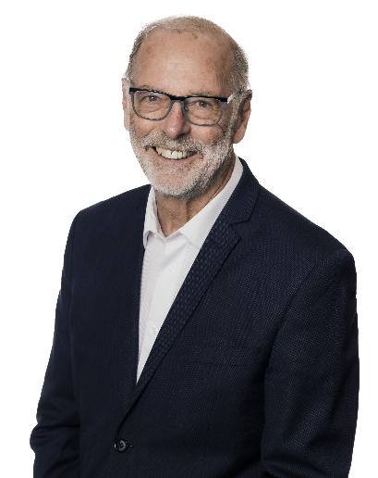
Wayne Brown
Mayor of Auckland

Our vision
The longer-term vision is a more efficient council focussed on value for money for Aucklanders.
Our vision is to create an Auckland that is beautiful, thriving and safe. This includes:
- a stunning natural environment – harbours, beaches, forests, maunga, islands, urban trees –
that can be accessed and enjoyed by Aucklanders across the region
- a transport system and development pattern that enables us to live in decent houses
in nice communities and move around the region easily, affordably and in a way that
meets our climate commitments
- decent and affordable public services, amenities, and infrastructure
- a diverse and dynamic city, which honours the place of Māori and includes a rich array
of cultural and sporting events, museums, galleries and built heritage
- a thriving economy that supports growth and opportunities for all.

Progress against our plan
We adopted our Long-term Plan 2024-2034 in June 2024. Here are some of the highlights of what we have delivered since then.

Major projects and community development, activities and services
- completed the Te Whau Pathway between the Northwest Cycleway (SH16) and Roberts Field in Te Atatu South
- made progress on city centre projects including the reopening of Beresford Square and the return of bus services to the full length of Albert Street as part of the City Rail Link (CRL) development
- opened the 600m-long Rā Hihi flyover that connects the South Eastern Highway and Pakūranga Road
- opened the 19ha Ōpaheke Park in Papakura which includes wide green fields, 2kms of walking paths, 50,000 new plants and trees, wetlands and a pump track
- upgraded and improved facilities at playgrounds in Barry Curtis Park, Flat Bush and Achilles Crescent Reserve on the North Shore
- built sports courts at Mayfield Park in Ōtara
- renewed the roof at Glenn Innes Library
- completed the new Jubilee Bridge which restores a popular walking and cycling track for communities on both sides of the Panmure Basin
- renewed Albany Coronation Hall and Memorial Library exterior renewals and hall storage room to improve functionality and preserve character
- upgraded Highland Park Library canopy and toilet.
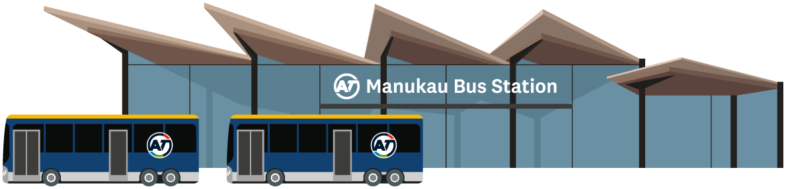

Water networks and flood resilience
- progressing a $38.3 million upgrade of the Wellsford Wastewater Treatment Plant
- opened the Snells Beach Wastewater Treatment Plant, marking a significant milestone in a $450
million programme to transform wastewater services for the Warkworth and Snells Beach/Algies Bay communities
- completed the outfall tunnelling further south at Clarks Beach. The outfall is a key part of a broader
infrastructure programme designed to support population growth in south-west Auckland
- progressing with design and construction of four blue-green networks in Māngere, Wairau and
Rānui which, once completed, will significantly reduce flood risk for hundreds of homes
- funded 15 community and iwi groups to deliver flood resilience education to Aucklanders
- progressing buyouts of properties as part of managing Auckland’s resilience to climate change
events
- installed over 2300 manhole safety grills to reduce injuries and public access during storms.

Auckland Future Fund
The Auckland Future Fund Board appointed Vontobel as its global investment manager to oversee $1.3 billion of funds on Auckland Council’s behalf. The investments will provide additional funding for council services and infrastructure, and reduce reliance on rates.

Financial separation of Watercare
Watercare became financially separate from Auckland Council. This means it borrows money in its own name to pay for water infrastructure like pipes and treatment plants, instead of borrowing through the council.
With the ability to borrow more money, Watercare can keep prices lower than would otherwise be possible and have greater certainty in delivering new and upgraded infrastructure for Tāmaki Makaurau.
There are no changes to Watercare’s financial reporting which are still included in the Auckland Council group’s overall financial accounts.

What we are planning
Our proposed Annual Plan 2026/2027 focuses on getting on with year three of our Long-term Plan (LTP) 2024-2034. It continues to progress the financial and physical resilience committed to in our LTP, while building a more efficient council focussed on value for money for Aucklanders.

Our priorities
We are prioritising investment in transport, water and enabling local boards to respond to their communities’ needs.

Key programmes across seven investment areas
We will spend $3.9 billion on major building and infrastructure projects across Auckland, like roads, public transport, parks and community facilities.
We will also fund $5.3 billion for essential services and activities that Aucklanders use every day.
(See page 10 for ‘Plan at a glance’).

City Rail Link - main reason for rates rise
A major highlight this year is the expected opening of the City Rail Link (CRL). This will transform Auckland’s public transport and also bring economic and environmental benefits to Auckland.
The ownership and operating costs of CRL, the bulk of which is interest and depreciation costs for the council’s share of CRL, are the main reason for the planned 7.9 per cent rates increase for an average-value residential property. (See page 14 for ‘City Rail Link’). 

Funding local services and infrastructure
Local boards are responsible for services that strengthen communities in their area. These services include parks, libraries, pools, arts, recreation centres, community halls, programmes and events, as well as support for local community groups and environmental initiatives.
Local boards will decide which activities and services to focus on in their area, based on the funding available, including $15 million more in 2026/2027. With the increasing costs of running facilities, this might require small service level changes, or in some cases considering targeted rates.
(See pages 20-43 for ‘Local Board’).

Getting the most out of every dollar
The council continues to focus on delivering its savings targets and prudently managing debt.
Our ongoing savings target increases in 2026/2027 by $20 million to $106 million. (See page 16 for ‘Financial overview’).

A 7.9% rates rise for average value residential properties due mainly to CRL costs
An overall rates increase of 7.9 per cent is planned (for the average-value residential property), as previously agreed in the Long-term Plan 2024-2034. The increase in rates is mainly due to the $235 million yearly cost to run and own the City Rail Link, the bulk of which is interest and depreciation costs for the council’s share of CRL.
Although the overall rates increase is higher than we would like, our focus on savings and efficiency has helped keep the increase much lower than what it could have been. (See pages 45-49 for ‘Your rates’).
We encourage you to read more in this document before giving your feedback. (Feedback form see page 54).
Feedback must be received by 11.59 PM on Sunday 29 March 2026.

Proposed Annual Plan 2026/2027 at a glance
There are seven areas of council activities, or investment, that contribute to the vision for Auckland. The following is what we’re planning to deliver in 2026/2027:
Operational expenditure* TOTAL $5,279m
Capital expenditure TOTAL $3,940m
*Operating expenditure figures exclude depreciation and amortisation expense.
For more information, see pages 12-14 of the Consultation Document and section two of the Supporting Information.

Transport
Operational expenditure $1,830m, Capital expenditure $1,472m
- Implement transport reform legislation, which includes:
  - refocus council's transport CCO to focus on public transport delivery
  - transfer of most of Auckland Transport's current functions to council, providing greater democratic accountability for transport decisions and strengthen integration with other council activity.
  - jointly planning transport with central government over the long term through new 10 and 30 year plans.
- Progress the construction of the Eastern Busway.
- Support City Rail Link go-live, focusing on operations with new services running in 2026.
- Continue level crossings removal in Glen Innes and Takanini.
- Deliver other planned capital works including:
  - asset renewals
  - road safety projects
  - ferry fleet replacement
  - Rosedale bus station construction
  - Carrington Road improvements.

Water
Operational expenditure $829m Capital expenditure $1,551m
- Continue work funded by the Water Quality Targeted Rate programme, including completing the Lower Khyber separation works to improve Eastern Isthmus water quality.
- Renew and upgrading critical assets such as the East Tāmaki Dam and Paremuka Dam culverts.
Advance the Making Space for Water programme that aims to reduce, avoid and raise awareness of flood risks.
- Complete a new wastewater pump station, a new 4.6km wastewater pipeline and a new watermain in Waiwera to cater for growth.
- Bring the second northern half of the 16.2km Central Interceptor wastewater tunnel into service,
increasing conveyance capacity and reducing wet-weather overflows into inland waterways.
- Continue the $500m water and wastewater renewals programme to replace ageing pipes and treatment plant infrastructure across Auckland.

Built environment
Operational expenditure $72m, Capital expenditure $150m
- Collaborate with Kāingā Ora and the Ministry of Housing and Urban Development to progress infrastructure investment in the Auckland Housing Programme areas of Māngere, Tāmaki, and Mt Roskill.
- Progress city centre regeneration programmes including completion of public spaces around CRL stations and Te Hā Noa
- Victoria Street; further development of High Streets and Te Toangaroa.
- Maintain momentum on current urban development programmes, including Drury, while reassessing priority locations such as Northcote, Henderson, Avondale and Manukau, and continue identifying new areas for growth based on service needs, potential benefits and the council’s role.
- Updating planning rules to support a more compact city by focusing growth around well‑connected centres and transport corridors, strengthening hazard protections, and meeting new national planning and environmental requirements.

Natural environment
Operational expenditure $752m, Capital expenditure $76m
- Meet the council’s obligations in the Regional Pest Management Plan 2020-2030 and increased
funding and extension of the pest plan, animal and pathogen control and restoration activities.
- Coordinate and implement the Kauri Dieback Management Programme to protect our kauri forests.
- Undertake marine biosecurity education and engagement programmes, increased surveillance and
monitoring of existing and emerging marine pests, such as the exotic caulerpa seaweed.
- Expand the network of resource recovery facilities around the region, including Community Recycling Centres that receive, collect, repair and refurbish unwanted items from the public.

Community
Operational expenditure $967m, Capital expenditure $367m
- Provide advice to local boards on service levels, revenue options and new investments through fairer funding.
- Continue increased funding for the Sports and Recreation Facilities Investment Fund to address the deficit in some sports facilities in Auckland.
- Continue to deliver differently by transitioning of community services from a dependence on assets to more innovative ways.
- Progress urgent community asset renewals to safeguard our facilities from asset failure and support high-priority growth projects.
- Focus on education for responsible dog ownership, improving compliance, expanding animal shelter capacity, and controlling the dog population through increased desexing.
- Improve community safety and reduce public nuisance through the use of safety and compliance wardens and community partners.

Economic and cultural development
Operational expenditure $210m, Capital expenditure $77m
- Work with central government on new funding tools for visitor attraction and economic development, including exploring a bed night visitor levy for major events and destination marketing.
- Continue to deliver iconic cultural events such as Pasifika, Diwali and the Lantern Festival.
- Continue to provide experiences for visitors to the Auckland Zoo, Auckland Art Gallery, and New Zealand Maritime Museum.
- Facilitate international and domestic events, including musicals, concerts and exhibitions.
- Continue development of a Stadium Investment Plan to ensure a fit-for-purpose, financially sustainable network aligned with regional and community priorities including the delivery of a locally led plan for North Harbour Stadium.

Well-managed local government
Capital expenditure $620m, Capital expenditure $246m
- Support the Auckland Future Fund Trustee Limited board to achieve long-term average annual returns of 7.24 per cent.
- Invest $16 million into Māori outcomes including the ongoing Marae Infrastructure Programme, and grants to improve the capacity of mana whenua and mataawaka to engage in Auckland Council decision-making processes.
- Progressing savings and efficiency actions, targeting an additional $106 million in savings by 2026/2027 across the council, along with the continued consolidation of the council group’s service functions and achieving asset recycling targets, which involves selling or leasing some of our lesser-used assets like land and buildings to help pay for new ones.
- Well-managed local government includes corporate support functions, third party amenity grants like those to fund the Museum of Transport and Technology (MOTAT) and expenditure incurred by Port of Auckland.

Major projects in progress for 2026/2027

North Auckland
Water treatment plant, Wellsford
Progressing a new a water treatment plant to meet the demands of a growing population.
East Coast Bays Community Centre
Extensive upgrade and building refurbishment.
Rosedale Bus Station
Progressing construction for a new busway station and multi-mode access improvements to Rosedale Road.
Te Kori Scott Park, Hobsonville
Develop a sustainable sport park.

West Auckland
Te Whau Pathway
Design and construction of the boardwalks/bridges and concrete paths between Wingate Street and Rata Street.
West Wave Aquatic Centre
Phase two focuses on the replacement of roofing, cladding, water heater gas boiler, dive pool lining and pool hall filtration system.
Te Hono / Avondale Community Centre replacement
Development of an integrated library and community centre hub.

South Auckland
Te Matariki Clendon Community Centre
Comprehensive renewal of the library and community centre building.
Level crossings removals
Works to improve remaining pedestrian rail crossings at some rail stations, particularly in Takanini.
Otaawhati – Ray Small Park
Upgrade playground and park amenities.
Te Hono / Avondale Community Centre replacement
Development of an integrated library and community centre hub.
Neighbourhood parks in Franklin
Bremner Road Drury, Ngakoroa Reserve Drury, Ray Fausett Reserve Pukekohe, Poohutukawa Park Glenbrook, Papahua Sports Park Pukekohe.

Central Auckland and Gulf Islands
Waiheke Onetangi Sportspark
Upgrading fields and lighting for community use.
Olympic Pools
Building structure strengthening and renewals.
Leys Institute
Comprehensive redevelopment given the breadth and depth of the works.
City Centre Programme
Delivering on the outcomes of the City Centre Masterplan to create a vibrant, accessible and inclusive city centre that contributes significantly to the Auckland region.

East Auckland
Eastern Busway
Progressing construction of the Pakūranga to Botany section of the Eastern Busway.
Colin Maiden Park
Develop sports fields and infrastructure.
David Lange Park destination playground
Stage 2 upgrades including a youth zone.

Region wide
Sports field capacity development programme
Developing, upgrading and renewing sports fields to increase sports field capacity across Auckland.
Central Interceptor
Watercare’s supersized tunnel will reduce wastewater overflows into central Auckland waterways.
Land acquisitions
Acquiring land for parks and open spaces to contribute to Aucklanders’ quality of life, as well as make better use of the parks we already have.
Urban regeneration
Strategically planning and investing in town centres, infrastructure and community amenities to enable sustainable development and support vibrant, connected neighbourhoods.
Moving transport forward
Developing new travel solutions and improving public transport.
City Rail Link (CRL)
CRL will be completed and operational in 2026. The 23 new trains, two new underground stations, new bus routes and improvements to the city centre’s public spaces will make travel around the region easier and the city centre more appealing for businesses, visitors and residents.

CRL - On track to deliver benefits
After nearly ten years of construction, Auckland’s City Rail Link (CRL) will open in 2026 bringing transport, economic and environmental benefits to Auckland.

Costs
Auckland Council has committed to fund 50 per cent of the capital costs of CRL, which is projected to be $5.5 billion at completion, and therefore the council’s share is $2.75 billion. Once the CRL is complete and opened the council will receive public transport revenues from usage and will also be required to fund operating costs.
The ownership and net operating costs for the CRL are projected to be $235 million per year. This includes Auckland Transport’s $26 million net operating costs for running additional stations and services, plus interest ($167 million) and depreciation funding requirement ($42 million).
The planned rates increase of 7.9 per cent for the average-value residential property is mainly due to the cost to run and own the council’s share of the City Rail Link. Over the longer term, the CRL is expected to support further growth in services and usage, although wider rail network investments will be required to achieve the full benefit.

The benefits
The CRL project is a significant investment in Auckland’s infrastructure and will be transformational for our region. New world-class stations, increased train frequency and improved access will encourage growth in jobs, and help reinvigorate Auckland.
The infrastructure investment will deliver a significant return on the council’s 50 per cent stake in the project. The city centre generates 21 per cent of Auckland’s GDP and has by far the highest concentration of jobs in New Zealand. CRL will double the number of people who can reach the city centre by public transport, significantly increasing connectivity.
In total 21,000 more residents, 17,200 more students and 37,000 jobs (these are current city centre residents / students and existing jobs) will be within a 12-minute walk of Karanga-a-Hape and Te Waihorotiu Stations. They will both be important transport interchanges.
Wellesley Street will accommodate over 140 buses per hour, so it is being rebuilt with a strengthened carriageway and much wider footways to let people move easily to and through the area.
Almost 75 per cent of passengers at Karanga-a-Hape are expected to transfer to/from trains and buses in the morning peak.
By turning Waitematā Station from a station where tracks ended into one that tracks continue through, we’ll be able to increase train frequencies into the city, to the south and west of Auckland. The regional benefits are considerable. For example, post-CRL if you're travelling from Henderson peak morning to midtown, you’ll save 24 minutes in travel time. It will also mean you can travel directly to the south.
Auckland’s integrated transport system brings the benefits of CRL to the whole region, whether or not people have a local railway station. For people living on the North Shore or in the eastern suburbs, they can connect to trains via rapid and/or frequent buses.
CRL is more than just a 3.45 km tunnel; it is the centrepiece of a significant improvement in public transport connectivity, capacity and level of service.
These improvements will inform a refresh of Auckland’s City Centre Masterplan, to reflect the new travel patterns and possibilities for the heart of New Zealand's most important city.

The CRL is expected to produce $12 billion of economic benefits:
Travel time $5.1b
Increased productivity $4.2b
Improved reliability $1.6b
Other including walking, decongestion and environmental $1.1b
Total $12.0b
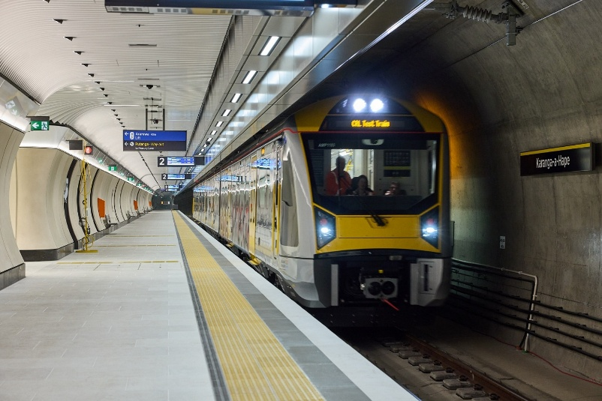

Financial overview
Auckland Council Group’s financial strategy, as set out in our LTP, seeks to improve Auckland’s physical and financial resilience over the next decade. It provides a strategic roadmap to support financial stability while enabling long-term sustainable growth and development.
The Annual Plan 2026/2027 is being developed in a more stable economic environment than in recent years, with some ongoing risk areas that continue to be monitored. Inflationary pressures, while elevated in recent years, have moderated. As a result, at the time of writing, the council group’s financial forecast remains broadly in line with the third year of the LTP.
This section provides a high-level overview of the council group’s key financial projections for the 2026/2027 financial year (year three of the LTP).
Category | Year 1 Actuals  2024/2025 | Year 2 Annual Plan 2025/2026 | Year 3 Projected 2026/27
Total capital investment* | $3,927m | $4,274m | $3,940m
Total operating expenditure | $6,673m | $6,654m | $6,973m
Average residential general rates increase | 6.80% | 5.80% | 7.90%
Rates revenue | $2,786m | $3,035m | $3,357m
Total operating funding sources | $5,844m | $6,258m | $6,726m
Total assets | $79,730m | $82,181m | $90,498m
Net debt | $14,113m | $15,607m | $17,595m
Total equity | $59,144m | $60,462m | $66,660m
Debt to revenue ratio | 247% | 224% | 225%
* The transport capital programme has been updated to reflect changes in National Land Transport Programme (NLTP) funding assumptions since the adoption of the LTP. The figures above also reflect the impact of Category 3 buyouts and other minor budget adjustments across the council group.
Detailed financial projections and key assumptions are included in section two of the Supporting Information.

Financial flexibility
A number of budget risks beyond the council's control may impact the financial projections for 2026/2027. This includes, among others, the emergence of several cost pressures, a sudden change in economic conditions or a significant storm event. These risks are considered more manageable than in recent budget cycles and the council will continue to review budgets to address them while delivering the key commitments set out in the LTP.
At this stage, there is no pressing need to depart from the projected rates increases or other core financial settings assumed in the LTP, other than the specific matters being consulted on as part of this annual plan. However, should any financial risks materialise, budget adjustments may be required as budgets are refreshed later in the year, potentially affecting operating expenditure, capital investment, asset recycling assumptions, and, as a last resort, rates.
In a worst-case scenario, the council might consider a rates increase for the average residential property by 1-2 per cent more than projected in the LTP. Debt levels could be marginally higher but still within the 250 per cent prudential policy limit. Should more significant changes be required, then the council would undertake public consultation before final decisions.
While there is no current intention to deviate from the LTP settings, it is prudent for council to remain prepared to respond to changing circumstances and emerging risks. See Sections 2.3 and 2.4 of the Supporting Information for more information on budget risks and their implications on financial settings.
Ki tua o te mahere ā-tau – te tārai i te anamata o Tāmaki Makaurau

Beyond the annual plan – shaping Auckland’s future
Looking beyond the Annual Plan 2026/2027, a number of key strategic discussions provide an opportunity to transform Auckland.
These strategic discussions will include regional transport plans, water service strategies, Auckland’s spatial (or land-use) plan and our Long-term Plan 2027-2037.
The mayor and councillors will provide direction to the council group on these opportunities. To help inform that, we would like to hear from Aucklanders about the possible shape of Auckland’s future, and priorities for investment.
To achieve what we want for Auckland, there are several key issues to be addressed by Auckland Council including:addressing productivity and growth challenges
- infrastructure investment to support population growth
- protecting and enhancing our existing assets
- building climate resilience and environmental sustainability
- meeting the diverse needs of our communities
- delivering the services and activities Aucklanders need within financial constraints.
Decisions on these issues will impact the daily lives of Aucklanders.
For example, transport planning shapes the way we connect people, activities and services by developing strategies for multimodal systems (cars, public transport, cycling and walking). Transport decisions also support productivity and economic growth, if we design networks that are integrated with land-use and reduce congestion.
Similarly, our spatial or land-use planning makes a difference by creating more connected, sustainable and liveable communities that also address the challenges we have such as population growth, housing needs, infrastructure demands and environmental impacts of growth.
At the heart of this are our communities, where we can focus investment on better social connection, access to services and ensuring more Aucklanders benefit from growth in the region.
At the same time, we will need to ensure our region continues to be resilient to issues like managing climate change, balancing growth with protecting our natural environment and ensuring we have a resilient, beautiful and thriving Tāmaki Makaurau for future generations.
These and other matters are discussed in the Mayoral Proposal, and in several documents that collectively set a strategic framework for our planning, focus and accountability. These include:
- The Auckland Plan
- The Auckland Future Development Strategy
- Tāmaki Ora Māori Outcomes
- The Auckland Unitary Plan
- Te Tāruke-ā-Tawhiri: Auckland’s Climate Plan, and
- The Auckland Council Long-term Plan 2024-2034.
As we look at the future direction for these and other strategies, we want to know what you think about the council’s long-term priorities, including the future for our city centre.
Please see page 54 to provide feedback on areas you think the council should focus on for Auckland’s long-term future.
Part 2
Ngā poari ā-rohe

Local boards

Working in the heart of our communities
Local boards are responsible for servicesthat strengthen communities in their area.
These services include:
- parks
- environmental initiatives
- libraries
- pools
- arts
- recreation centres
- community halls
- community programmes
- events and support for local community groups.
The Governing Body approved a ‘fairer funding’ approach for local boards in the LTP 2024- 2034. This was to address the funding imbalances between the 21 local boards that have been in place since Auckland Council was established in 2010.
The ‘fairer funding’ approach allocates available funding to local boards based on an ‘equitable funding level’. This is calculated according to each local board’s:
- population (80 per cent)
- levels of deprivation (15 per cent)
- land area (5 per cent).
To support the transition to this new equitable approach, local boards will receive an extra $15 million of operating funding in 2026/2027 compared with 2025/2026. Currently some local boards are funded at or above the equitable funding level and some local boards are funded below the equitable level.
Boards that are funded below the equitable level will receive additional funding in 2026/2027. Boards that are already funded at or above equitable levels will not receive additional funding and like all boards are also facing cost increases due to rises in the cost of delivering existing services in 2026/2027.
Local boards will make decisions on the activities and services provided in their local area within the available funding. This could involve reprioritising spend to address the growing costs of running community facilities or introducing a local services targeted rate to maintain service levels. Where these changes may result in significant service level impacts, the Governing Body has tools available to assist with funding issues.

Your feedback
Each of the local boards have set out their plans for next year on pages 19 - 43 and want to hear from you about what matters most to you in your local board area. Your feedback will help local boards make informed decisions about where to prioritise funding.

Our grants programme
To find out about our grants programme to support community-led initiatives and how to apply, visit:www.aucklandcouncil.govt.nz/whataregrants
Ngā Poari ā-Rohe

Local boards
Local boards will decide which activities and services to focus on in their area, based on the funding available. The table below shows how we propose to use local board funding.

Key areas of spend 2026/2027

Planned capital spend to renew and develop assets
Local community services $244.3m
Local environmental services – not applicable
Local planning services – not applicable
Local governance – not applicable
Total $244.3m

Planned operating spend to maintain and operate assets and deliver local activities
Local community services $443.2m
Local environmental services $12.9m
Local planning services $25.7m
Local governance $23.4m
Total $505.2m

Local board area map
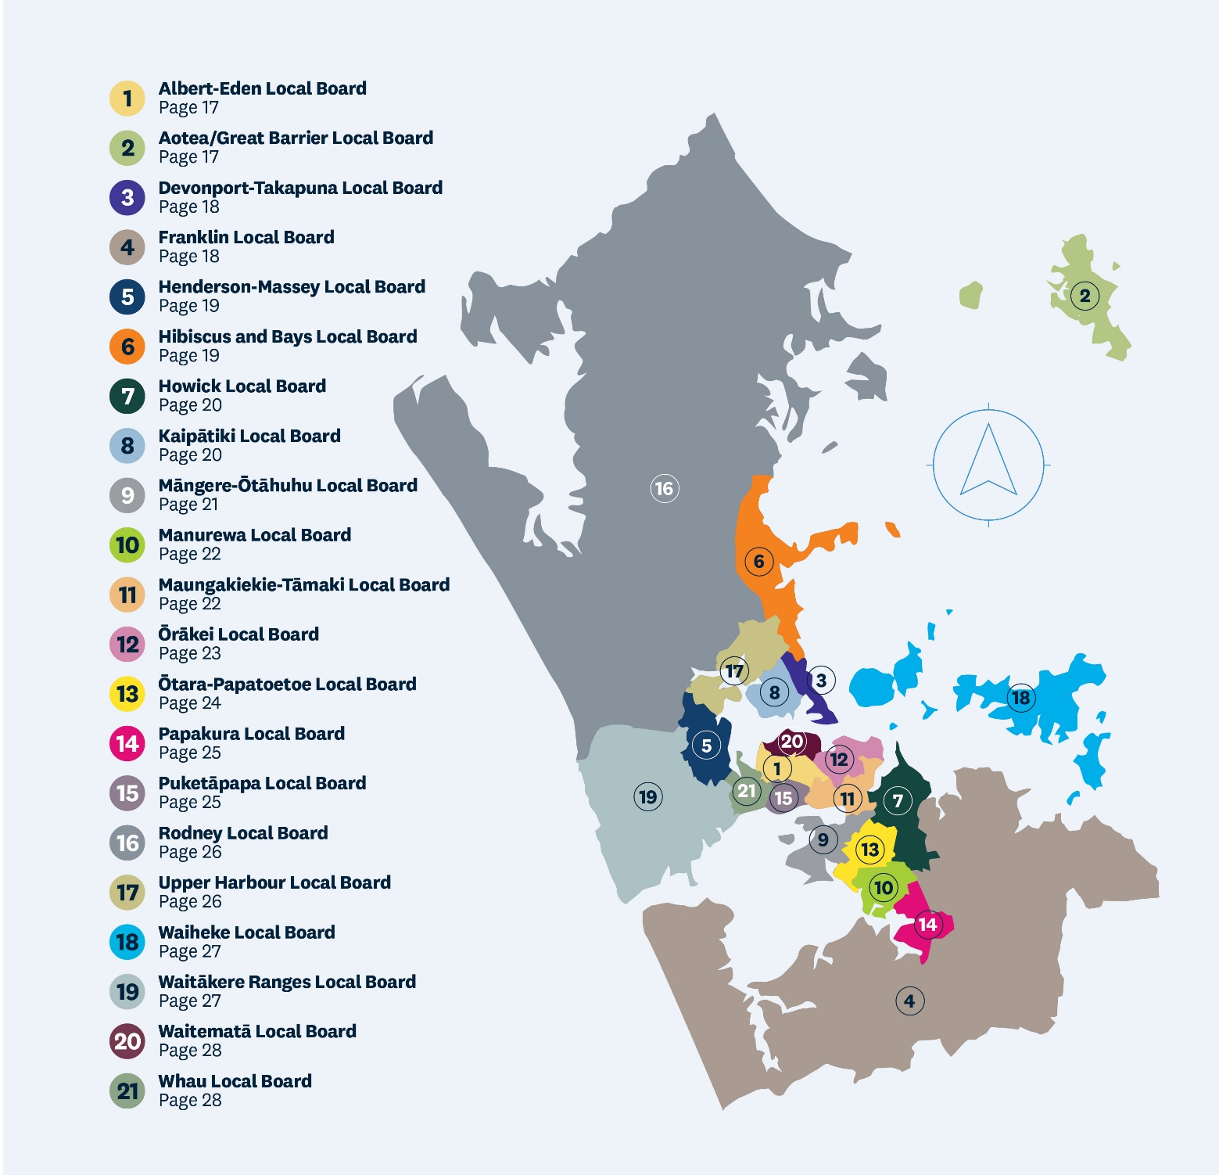
Find your local board on the Auckland Council website.
- Albert-Eden Local Board Page 22
- Aotea/Great Barrier Local Board Page 23
- Devonport-Takapuna Local Board Page 24
- Franklin Local Board Page 25
- Henderson-Massey Local Board Page 26
- Hibiscus and Bays Local Board Page 26
- Howick Local Board Page 28
- Kaipātiki Local Board Page 29
- Māngere-Ōtāhuhu Local Board Page 30
- Manurewa Local Board Page 31
- Maungakiekie-Tāmaki Local Board Page 32
- Ōrākei Local Board Page 33
- Ōtara-Papatoetoe Local Board Page 34
- Papakura Local Board Page 36
- Puketāpapa Local Board Page 37
- Rodney Local Board Page 38
- Upper Harbour Local Board Page 39
- Waiheke Local Board Page 39
- Waitākere Ranges Local Board Page 40
- Waitematā Local Board Page 42
- Whau Local Board Page 43
Te Poari ā-Rohe o Albert-Eden

Albert-Eden Local Board

The Albert-Eden Local Board has been allocated $7.9 million for capital investment and $24.9 million for operational expenditure. A large part of this operational expenditure is committed to contracts for maintaining our community facilities and open spaces. For a breakdown of current operational spend please see the supporting information.
The local board has been allocated additional funding in 2026/2027, but some of this additional funding for operational expenditure will be needed to address cost increases outside of our control due to unavoidable rises in the cost of delivering existing services, such as utilities, asset maintenance and staffing requirements.
Taking into consideration indicative cost increases to existing services, the local board has an additional $0.3 million for operational expenditure compared to current funding.

What we plan to deliver in 2026/2027
- Continue to deliver the local services, projects and programmes that are important to our community.
- Deliver additional investment in key areas and changes to services / fees and charges, specifically:
- restoration planning for Waitītiko / Meola Creek, to leverage the improvements in water quality that will be achieved through the Central Interceptor (which is nearing completion)
- investigating how to respond to future growth expected in our area as a result of Proposed Plan Change 120: Housing Intensification and Resilience, the opening of the City Rail Link and development areas like Te Kukūnga Waka (Carrington residential development) and any future changes at the ex-University of Auckland, Epsom Campus
- trialling free off-peak access for Gold Card holders to swim at Mt Albert Aquatic Centre.

Key projects planned for 2026/2027
- continue delivering the initiatives identified in the Windmill Park and Chamberlain Park Concept Plans
- confirm where to cover outdoor sport court sites in the local board area and complete planning and design for the selected site
- fix the Epsom Library roof and provide an alternative library service during construction
- continue planning for a permanent, long-term solution for Pt Chevalier library and community hub and investigate how a new hub might support wider town centre invigoration
- renew Coyle Park playground, Phyllis Reserve fields and the roof at Mt Albert Library.
For more information see section 1.1 of the Supporting Information.
Te Poari ā-Rohe o Aotea/Great Barrier

Aotea/Great Barrier Local Board
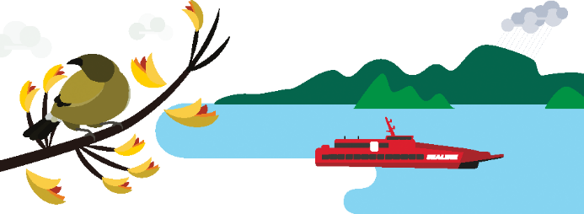
The Aotea / Great Barrier Local Board has been allocated $1.6 million for capital investment and $4.1 million for operational expenditure. A large part of this operational expenditure is committed to contracts for maintaining our open spaces and via grant funding for maintenance of our community-owned community facilities. For a breakdown of current operational spend please see the supporting information.
The local board has been allocated additional funding in 2026/2027, but some of this additional funding for operational expenditure may be needed to address cost increases outside of our control due to unavoidable rises in the cost of delivering existing services, such as utilities, asset maintenance, staffing requirements as well as pressures on revenue.

What we plan to deliver in 2026/2027
- Continue to deliver the local services, projects and programmes that are important to our community.
- Deliver additional investment in key areas and changes to services, specifically:
- improvements to the library service including additional programmes
- partnering with mana whenua and community on moana ora (marine wellbeing) projects such as island fisheries management and local Ahu Moana marine projects.

Key projects planned in 2026/2027
- annual grants to community groups to continue delivering health, wellbeing, resilience, waste, environment, and education services for the island
- renewals of the walking tracks, parks and playgrounds.
For more information see section 1.2 of the Supporting Information.
The local board has been allocated additional funding in 2026/2027, but some of this additional funding for operational expenditure may be needed to address cost increases outside of our control due to unavoidable rises in the cost of delivering existing services, such as utilities, asset maintenance, staffing requirements as well as pressures on revenue.v
Te Poari ā-Rohe o Devonport-Takapuna

Devonport-Takapuna Local Board

The Devonport-Takapuna Local Board has been allocated $6.6 million for capital investment and $16.9 million for operational expenditure. A large part of this operational expenditure is committed to contract for maintaining our community facilities and open spaces. For a breakdown of current operational spend see the supporting information.
Through the Long-term Plan 2024-2034 the council moved to a new funding model for local boards. As a result, it is now the local board’s responsibility to address changes to the cost of delivering services. The local board is facing cost increases outside of our control due to unavoidable rises in the cost of delivering existing services, such as utilities, asset maintenance, staffing requirements as well as pressures on revenue. As a result, the local board may need to make difficult decisions to address these.
The indicative cost increase to deliver existing services is $0.6 million in operational expenditure. This indicative amount may change before the final Annual Plan decisions are made.

Changes to current service levels
To address the cost increases we are facing, the local board could make some or all of the following changes service levels:
Maintenance: reduced maintenance of bollards and fencing, stop scheduled maintenance for bush area (except high value/ecological areas), reduced service level for amenity gardens and planted areas, and reclassifying re-vegetation areas to bush areas.
- Library hours: reduced library opening hours
- Events funding: reduced funding to local organisations that deliver local events
- Contestable grant funding: reduced contestable grants budget
- Operational funding grants: reduced funding support for local community, recreation, ethnic, seniors and youth groups
- Arts facilities and programmes: reduced operational grants to arts partners
- Volunteers: reduced funding for local parks volunteers
- Operational funding grants for environmental programmes: reduced funding support for restoration, planting, pest management and waste minimisation.
- For more information see section 1.3 of the Supporting Information.
Te Poari ā-Rohe o Franklin

Franklin Local Board

The Franklin Local Board has been allocated $10.9 million for capital investment and $26.1 million for operational expenditure. A large part of this operational expenditure is committed to contract for maintaining our community facilities and open spaces. For a breakdown of current operational spend please see the supporting information.
The local board has been allocated additional funding in 2026/2027, but some of this additional funding for operational expenditure will be needed to address cost increases outside of our control due to unavoidable rises in the cost of delivering existing services, such as utilities, asset maintenance, staffing requirements as well as pressures on revenue.
Taking into consideration indicative cost increases to existing services, the local board has an additional $630,000 for operational expenditure compared to current funding.

What we plan to deliver in 2026/2027
- Continue to deliver the local services, projects and programmes that are important to our community.
- Allocate any additional operational funding to existing community, environmental and local economic development service improvement programmes, for example, Franklin Sport and Recreation Facility investment programme, Pest-Free Franklin programme, Franklin Waterway Protection Partnership programme and the Franklin Community Partnership programme.
- Allocate any additional capital funding to advance key and approved capital projects, including those within the Franklin facility renewals programme, where these are deliverable within the financial year.

Key projects planned in 2026/2027
- activate Beachlands Community Hub to enable delivery of local arts, library and customer services in Beachlands-Maraetai
- progress development of Papahua sports park and a Pukekohe Community and Civic Hub in Pukekohe
- develop options to address community safety and environment at Karioitahi Beach
- deliver stages 1, 2 and 4 of the Clevedon Village Heart project
- progress delivery of the Paparata Local Purpose Reserve (Bombay) concept plan
- continue to seek options for the development of Clarks Beach Reserves in line with future need.
- continue to invest in the Franklin Local Economic Development programme
- continue to invest in community led pest management and environmental restoration programmes.
For more information see section 1.4 of the Supporting Information.
Te Poari ā-Rohe o Henderson-Massey

Henderson-Massey Local Board
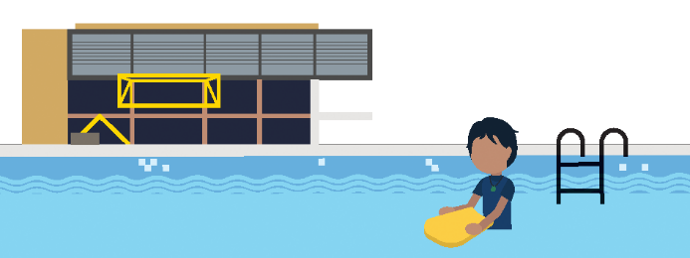
The Henderson-Massey Local Board has been allocated $ 22.0 million for capital investment and $37.8 million for operational expenditure. A large part of this operational expenditure is committed to contracts for maintaining our community facilities and open spaces.
Through the Long-term Plan 2024-2034 the council moved to a new funding model for local boards. As a result, it is now the local board’s responsibility to address changes to the cost of delivering services within their funding allocated. The local board is facing cost increases outside of our control due to unavoidable rises in the cost of delivering existing services, such as utilities, asset maintenance, staffing requirements as well as pressures on revenue. As a result, the local board will need to make difficult decisions to balance its budget.
The cost increase to deliver existing services is $0.6 million in operational expenditure. This indicative
amount may change before the final Annual Plan decisions are made.

Changes Changes to current service levels
To address the indicative cost increases, the local board will have to reduce some or all the following service levels:
- reduce library hours - Close Te Manawa on Thursdays at 7pm instead of 9pm, changing from a 7 day/67 hour service to 7 day/65 hour service
- reduce maintenance - Stop scheduled bollard & post-and-rail maintenance, stop scheduled maintenance for bush areas (except high-value/ecological areas), cease infill planting and mulching in amenity gardens, and reclassify re-vegetation areas to bush areas.
For more information see section 1.5 of the Supporting Information.
Te Poari ā-Rohe o Hibiscus and Bays

Hibiscus and Bays Local Board

The Hibiscus and Bays Local Board has been allocated $10.3 million for capital investment and $31 million for operational expenditure. A large part of this operational expenditure is committed to contracts for maintaining our community facilities and open spaces. For a breakdown of current operational spend please see the supporting information.
The local board has been allocated additional funding in 2026/2027, but some of this additional funding for operational expenditure will be needed to address cost increases outside of our control due to unavoidable rises in the cost of delivering existing services, such as utilities, asset maintenance, staffing requirements as well as pressures on revenue.
Taking into consideration cost increases to existing services, the local board has an additional $0.7 million for operational expenditure compared to current funding.

What we plan to deliver in 2026/2027
- Continue to deliver the local services, projects and programmes that are important to our community.
- Deliver additional investment in key areas and changes to services / fees and charges, specifically:
- supporting further protection of our sea, soil and fresh water from contamination and sedimentation, through increased monitoring and extending projects such as local stream restoration including the Weiti River
- supporting community access to a wide range of recreational opportunities through investigating new capex projects such as outdoor court provision and increasing support for indoor court provision through facilities grants
- creating safer town centres and other public spaces through actions such as an increased support for community safety and placemaking
- ensuring Hibiscus and Bays is welcoming and supportive for all through collaboration with a broader range of local residents and an increased focus on inclusive design, so it is accessible and usable for people of all ages, abilities and backgrounds
- introducing changes to a range of fees in pools and leisure centres, including casual recreation, dry and aquatic group fitness and pool lane hire to better align fees across our sites.

Key projects planned in 2026/2027
- refurbish the East Coast Bays Community Centre
- deliver a permanent pump track at Red Beach
- deliver a permanent pump track as part of Awaruaika – the youth park at Streamview Way Park, Long Bay
- renew sports fields including at Freyberg Park and the Victor Eaves Park cricket ground
- renew the skatepark at Stanmore Bay.
For more information see section 1.6 of the Supporting Information.
Te Poari ā-Rohe o Howick Local Board

Howick Local Board

The Howick Local Board has been allocated $15.1 million for capital investment and $38.4 million for operational expenditure. A large part of this operational expenditure is committed to contracts for maintaining our community facilities and open spaces. For a breakdown of current operational spend please see the supporting information.
The local board has been allocated additional funding in 2026/2027, but the additional funding for operational expenditure will be needed to address cost increases outside of our control due to unavoidable rises in the cost of delivering existing services, such as utilities, asset maintenance, staffing requirements as well as pressures on revenue.
Taking into consideration indicative cost increases to existing services, the local board has an additional $560,000 for operational expenditure compared to current funding.

What we plan to deliver in 2026/2027
Continue to deliver the local services, projects and programmes that are important to our community.
- Deliver in key areas, specifically:
- explore ways to get the best value from our play spaces so they continue to meet the needs of children and families
- run regular seminars for community groups/organisations on the local grant's application process
- identify what type of indoor/sheltered courts are necessary to support sports play in Flat Bush
- continue advocacy of the Tāmaki estuary on water quality and coastal erosion
- continue to advocate to crime prevention organisations on behalf of the community for ongoing safety initiatives
- support our volunteer groups with resources needed for ecological volunteering, such as stream clean-ups and pest plant weeding.

Key projects planned in 2026/2027
- continuation of the temporary library in Flat Bush
- installation of new dump station at Half Moon Bay
- continue to develop the permanent library, community and aquatic leisure centre in Flat Bush
- install drinking fountains across the local board area
- develop the park at Ostrich Farm.
For more information see section 1.7 of the Supporting Information.
Te Poari ā-Rohe o Kaipātiki

Kaipātiki Local Board
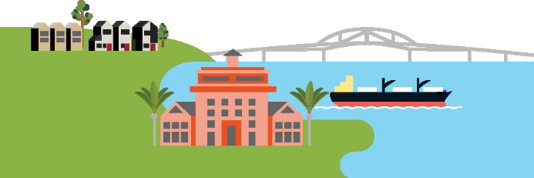
The Kaipātiki Local Board has been allocated $9.8 million for capital investment and $27.0 million for operational expenditure. A large part of this operational expenditure is committed to contract for maintaining our community facilities and open spaces. For a breakdown of current operational spend see the supporting information.
Through the Long-term Plan 2024-2034 the council moved to a new funding model for local boards. As a result, it is now the local board’s responsibility to address changes to the cost of delivering services.
The local board is facing cost increases outside of our control due to unavoidable rises in the cost of delivering existing services, such as utilities, asset maintenance, staffing requirements as well as pressures on revenue. As a result, the local board will need to make difficult decisions to balance its budget.
The local board has been allocated an additional $1.1 million for operational expenditure in 2026/2027, however the indicative cost increase to deliver existing services is $1.5 million. This indicative amount may change before the final Annual Plan decisions are made.
Taking into consideration indicative cost increases to existing services, the local board has a reduction of $0.4 million for operational expenditure compared to current funding.

What we plan to deliver in 2026/2027
- Continue to deliver the local services, projects and programmes that are important to our community.
- To address the cost increases we are facing, the local board will have to make some or all of the following changes:
- make savings from activities that are due to be complete this financial year and don’t require any further investment in 2026/2027
- assess the success and value of pilot activities initiated in 2025/2026, and stop or reduce as required
- reduce some of the increased investment made to activities in 2025/2026, without substantially changing the outcomes sought
- utilise an expected uplift in revenue from pools and leisure fees and charges.

Key projects planned in 2026/2027
- invest in the maintenance and renewal of our parks, playgrounds, community buildings, recreation facilities, and other public spaces so they continue to meet our communities needs
- support a community-led approach for the delivery of relevant and diverse services that develop and connect the community
- support environmental groups, community volunteers, and our diverse communities to carry out environmental restoration projects, including stream clean-ups, habitat improvement, native riparian planting, and pest control
- deliver infrastructure that enables sport participation, including sports field lighting at Shepherds Park and McFetridge Park, and improved toilet and changing room facilities at Stafford Park
- make substantial progress on the planning and delivery of major local projects, including the Beach Haven Coastal Connection (Stage 3), Birkenhead War Memorial masterplan implementation, and improvements to Little Shoal Bay / Wai Manawa Reserve.
For more information see section 1.8 of the Supporting Information.
Te Poari ā-Rohe o Māngere-Ōtāhuhu

Māngere-Ōtāhuhu Local Board

The Māngere-Ōtāhuhu Local Board has been allocated $10.9 million for capital investment and $26.7 million for operational expenditure. A large part of this operational expenditure is committed to contracts for maintaining our community facilities and open spaces. For a breakdown of current operational spend see the supporting information.
Through the Long-term Plan 2024-2034 the council moved to a new funding model for local boards. As a result, it is now the local board’s responsibility to address changes to the cost of delivering services. The local board is facing cost increases outside of our control due to unavoidable rises in the cost of delivering existing services, such as utilities, asset maintenance, staffing requirements as well as pressures on revenue. As a result, the local board may need to make difficult decisions to address these.
The indicative cost increase to deliver existing services is $1.05 million in operational expenditure. This indicative amount may change before the final Annual Plan decisions are made.
To address the cost increases we are facing, the local board could make changes to some service levels / fees and charges or introduce a Local Services Targeted Rate, or a combination of these.

Changes to current service levels and fees and charges
Make some or all the following changes to current service levels / fees and charges:
- reduce library hours of up to minimum service level at 4 libraries (44 hours / 6 days a week at each library)
- reduce maintenance - Stop scheduled bollard & post-and-rail maintenance, stop scheduled maintenance for bush areas (except high-value/ecological), change garden edging to chemical application, cease infill planting and mulching in amenity gardens and reclassify re-vegetation areas to bush areas
- reduce discretionary funding for Grants, Community Wellbeing and Environment Management programmes and services
- increase fees and charges by $1 for “Plus” (Spa, Sauna and Steam room entry) services at Moana-Nui-ā-Kiwa Pool and Leisure Centre.
We could also make the following change. While it won't address the cost increase, it would reduce the amount required for the swimming pool targeted rate:
- charge adult visitors from outside the local board area at Moana-Nui-a-Kiwa Pool and Leisure Centre and Ōtāhuhu Pool and Leisure Centre (Toia).

Local Services Targeted Rate
Introduce a Local Services Targeted Rate of $47.11 (GST inclusive) per Separately Used or Inhabited Part per annum on all rateable properties except those categorised as zero-rated in the Māngere-Ōtāhuhu Local Board area ($0.91 cent per week). Unlike many other targeted rates that are ringfenced for a defined activity, this rate could be used for any local board operational expenditure. This will enable us to continue to deliver the local services, projects and programmes that are important to our community.
Noting that the local board would recommend the targeted rate to the Governing Body as decision to set targeted rates sits with them.

A combination of changes to current service levels / fees and charges and a Local Services Targeted Rate
A combination of Introducing a lower targeted rate to address some of the cost increase to deliver existing services and making some of the changes to current service levels / fees and charges to address the rest.
For more information see section 1.9 of the Supporting Information.
Te Poari ā-Rohe o Manurewa

Manurewa Local Board

The Manurewa Local Board has been allocated $28.7 million for capital investment and $7.6 million for operational expenditure. A large part of this operational expenditure is committed to contracts for maintaining our community facilities and open spaces. For a breakdown of current operational spend please see the supporting information.
The local board has been allocated additional funding in 2026/2027, but some of this additional
funding for operational expenditure will be needed to address cost increases outside of our control due to unavoidable rises in the cost of delivering existing services, such as utilities, asset maintenance, staffing requirements as well as pressures on revenue.
Taking into consideration indicative cost increases to existing services, the local board has an additional $0.5 million for operational expenditure compared to current funding.

What we plan to deliver in 2026/2027
- continue to deliver the local services, projects and programmes that are important to our community
- allocate up to $1.5 million of funding to support delivery of the Manurewa War Memorial Park multi-sports pavilion
- deliver a new multi-cultural initiative that responds to demands for increased ethnic engagement
- develop a civics education initiative that helps people understand the role of local boards and how they can get involved.

Key projects planned for 2026/2027
- continue to fund additional animal management team members and deliver initiatives that support dog safety and responsible ownership
- progress delivery of a new community hub at Te Pātaka Kōrero o Manurewa (Manurewa Library)
- continue improving our sports fields, including maintenance, sand-carpeting and lighting
- continue funding support for further delivery of the community’s Pan-Pacific Strategy
- continue to support ways to plant and retain more trees on public and private land and suburban streets
- continue to invest in our two illegal dumping pilot programmes: a proactive illegal dumping collection initiative and an illegal dumping enforcement programme
- deliver a new neighbourhood park at Glenveagh Reserve.
For more information see section 1.10 of the Supporting Information.
Te Poari ā-Rohe o Maungakiekie-Tāmaki

Maungakiekie-Tāmaki Local Board

The Maungakiekie-Tāmaki Local Board has been allocated $17.6 million for capital investment and $24.4 million for operational expenditure. A large part of this operational expenditure is committed to contracts for maintaining our community facilities and open spaces. For a breakdown of current operation spend please see the supporting information.
The local board has been allocated additional funding in 2026/2027, but some of this additional funding for operational expenditure will be needed to address cost increases outside of our control due to unavoidable rises in the cost of delivering existing services, such as utilities, asset maintenance, staffing requirements as well as pressures on revenue.
Taking into consideration indicative cost increases to existing services, the local board has an additional $1.4 million for operational expenditure.

What we plan to deliver in 2026/2027
- Continue to deliver the local services, projects and programmes that are important to our community.
- . Deliver additional investment in key areas, specifically:
- environmental initiatives – working alongside mana whenua on restoration projects, expanding food resilience and edible planting programmes, and reinstating deferred environmental education activities
- sport and recreation – providing one-off operational support to local sports clubs and facilities to strengthen participation and collaboration
- libraries and culture – enhancing programming for seniors and increasing investment in creative and cultural activities
- community safety and emergency readiness – exploring additional compliance officer resourcing in areas with limited coverage.
- local economy: supporting business associations to continue supporting local businesses and ongoing growth, development and liven-up our town centres.
- The Onehunga Business Association Inc are proposing to reduce the geographic boundary of the Onehunga Business Improvement District (BID) programme boundary area, and amount of targeted rate to be collected.

Key projects planned for 2026/2027
- expanding library programming, with particular emphasis on reaching and supporting communities most in need
- partnering with mana whenua and community groups on restoration, food resilience planting, and environmental education
- supporting local sports clubs and facilities to strengthen participation and collaboration
- exploring increased compliance resourcing and enhancing community emergency preparedness.
For more information see section 1.11 of the Supporting Information.
Te Poari ā-Rohe o Ōrākei

Ōrākei Local Board

The Ōrākei Local Board has been allocated $11.2 million for capital investment and $21.0 million for operational expenditure. A large part of this operational expenditure is committed to contract for maintaining our community facilities and open spaces. For a breakdown of current operational spend please see the supporting information.
The local board has been allocated additional funding in 2026/2027, but some of this additional funding for operational expenditure will be needed to address cost increases outside of our control due to unavoidable rises in the cost of delivering existing services, such as utilities, asset maintenance, staffing requirements as well as pressures on revenue.
Taking into consideration indicative cost increases to existing services, the local board has an additional $0.5 million for operational expenditure compared to current funding.

What we plan to deliver in 2026/2027
- Continue to deliver the local services, projects and programmes that are important to our community.
- Deliver additional investment in key areas, specifically:
- increase community-use sports fields provision either through redevelopment or expansion of our asset portfolio to address the forecasted move of Auckland Cricket into Colin Maiden Park and other demands on our sports fields
- increasing investment in restoration and pest-management programmes to grow and protect your natural environment. Our reserves and open spaces are one of the most vital resources in Ōrākei
- due to the current economic climate, it has been difficult to find private investment for a mixed-use housing and Meadowbank Community Centre. We are considering pivoting the project to a self-funded community centre to capitalise on existing investment and resources
- construct a playground at Remuera Library to optimise the under-used green space at the side of the building.

Key projects planned for 2026/2027
- the local board was successful in securing $2.5 million of the Fix & Finish Fund toward sports fields improvements to Thomas Bloodworth Park and Shore Road East bringing the total project fund to $5.75 million
- design and feasibility studies are in development for a breakwater seawall at Ōkahu Bay to provide boats with safe harbour access, enhanced marine recreation and continued growth of The Landing
- the Ōrākei community have asked for better, more effective communication from the board. As a result, digital signage will be installed to help keep everyone more informed about priority issues and what’s on
- continued investment in growing and protecting our parks and playgrounds.
For more information see section 1.12 of the Supporting Information.
Te Poari ā-Rohe o Ōtara-Papatoetoe

Ōtara-Papatoetoe Local Board
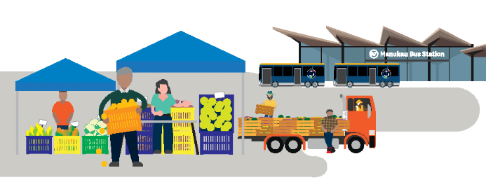
The Ōtara-Papatoetoe Local Board has been allocated $8.2 million for capital investment and $27 million for operational expenditure. A large part of this operational expenditure is committed to contract for maintaining our community facilities and open spaces. For a breakdown of current operational spend see the supporting information.
Through the Long-term Plan 2024-2034 the council moved to a new funding model for local boards. As a result, it is now the local board’s responsibility to address changes to the cost of delivering services. The local board is facing cost increases outside of our control due to unavoidable rises in the cost of delivering existing services, such as utilities, asset maintenance, staffing requirements as well as pressures on revenue. As a result, the local board will need to make difficult decisions to balance its budget.
The indicative cost increase to deliver existing services is $1.1 million in operational expenditure. This indicative amount may change before the final Annual Plan decisions are made.
To address the cost increases we are facing, the local board could make changes to some service levels / fees and charges or introduce a Local Services Targeted Rate, or a combination of these.

Changes to current service levels / fees and charges
Make some or all the following changes to current service levels / fees and charges:
- reduce maintenance:
  - Stop scheduled bollard and post-and-rail maintenance
  - Stop scheduled maintenance for bush areas (except High Value/Ecological)
  - Change garden edging to chemical application
  - Cease infill planting and mulching in amenity gardens
  - Reclassify re-vegetation areas to bush areas
- reduce library hours:
  - Ōtara Library - reduction 4 hours per week.
  - Papatoetoe Library – reduction 2 hours per week.
  - Tupu Youth Library – reduction 5 hours per week.
  - Manukau Library – close on Sundays reducing to a 6-day service.
- reducing discretionary funding for some activities - community grants, for community and/or environment projects
- increase fees for “Plus” (Spa, sauna and steam room entry) services by $1 at Ōtara Pool and Leisure Centre and Papatoetoe Centennial Pool (PCP)
We could also make the following change. While it won't address the cost increase, it would reduce the amount required for the swimming pool targeted rate:
- charge adult visitors from outside the local board area at Ōtara Pool and Leisure Centre and Papatoetoe Centennial Pool (PCP).

Local Services Targeted Rate
Introduce a Local Services Targeted Rate of $1.1 million capital value-based rate charged to all properties (This would be around $27 based on average-value urban residential property in the Ōtara-Papatoetoe Local Board area). Unlike many other targeted rates that are ringfenced for a defined activity, this rate could be used for any local board operational expenditure. This will enable us to continue to deliver the local services, projects and programmes that are important to our community.
Noting that the local board would recommend the targeted rate to the Governing Body as decision to set targeted rates sits with them.

A combination of changes to current service levels / fees and charges and a Local Services Targeted Rate
A combination of introducing a lower targeted rate to address some of the cost increase to deliver existing services and making some of the changes to current service levels / fees and charges to address the rest.
For more information see section 1.13 of the Supporting Information.
Te Poari ā-Rohe o Papakura

Papakura Local Board

The Papakura Local Board has been allocated $7.7 million for capital investment and $18.3 million for operational expenditure. A large part of this operational expenditure is committed to contracts for maintaining our community facilities and open spaces. For a breakdown of current operational spend see the supporting information.
Through the Long-term Plan 2024-2034 the council moved to a new funding model for local boards. As a result, it is now the local board’s responsibility to address changes to the cost of delivering services. The local board is facing cost increases outside of our control due to unavoidable rises in the cost of delivering existing services, such as utilities, asset maintenance, staffing requirements as well as pressures on revenue. As a result, the local board may need to make difficult decisions to address these.
The indicative cost increase to deliver existing services is $840,000 in operational expenditure. This indicative amount may change before the final Annual Plan decisions are made.

Changes to current service levels and fees and charges
To address the cost increases we are facing, the local board could make some or all of the following changes service levels fees and charges:
- reduce library hours at Sir Edmund Hillary Library: change to an earlier closing time of 5pm on Mondays and Fridays, and 2pm on Saturdays
- reduce selected maintenance: Stop bollard and post-and-rail maintenance in parks; stop scheduled maintenance for bush areas (except high-value/ecological)
- charge a higher fee for visitors outside the Auckland region who visit Massey Park Pool
- reduce or discontinue grant funding (both youth and community grants programmes)
- reduce the number of public rubbish bins in public spaces such as town centres, parks and reserves
- reduce or discontinue funding for: arts and culture activities, services and programmes in arts facilities and community centres, community development and support activities, environmental and water quality activities, civic events and sports and park activation activities.
For more information see section 1.14 of the Supporting Information.
Te Poari ā-Rohe o Puketāpapa

Puketāpapa Local Board

The Puketāpapa Local Board has been allocated $7.8 million for capital investment and $15.2 million for operational expenditure. A large part of this operational expenditure is committed to contract for maintaining our community facilities and open spaces.
The local board has been allocated additional funding in 2026/2027, but some of this additional funding for operational expenditure will be needed to address unavoidable cost increases of existing services.
Taking into consideration indicative cost increases to existing services, the local board has an additional $100,000 for operational expenditure compared to current funding.

What we plan to deliver in 2026/2027
- Continue to deliver the local services, projects and programmes that support our community and the environment.
- Deliver additional investment in key areas and changes to services / fees and charges (all fees and charges are subject to inflationary adjustments), specifically:
- investigating how to respond to the future growth expected in our area as a result of Proposed Plan Change 120: Housing Intensification and Resilience
- investigating how operational funding can be used for a Community Capital Grants Fund to improve the facilities available to the public.

Key projects planned for 2026/2027
- Monte Cecilia Park Masterplan
- Mt Roskill Library/Community Hub integration project
- deliver new neighborhood park at 3-7 Howell Crescent, Roskill
- continued implementation of the Puketāpapa Sports and Active Recreation Facilities Plan
- Wairaki Stream Ecological Enhancement and daylighting projects
For more information see section 1.15 of the Supporting Information.
Te Poari ā-Rohe o Rodney

Rodney Local Board

The Rodney Local Board has been allocated $10.5 million for capital investment and $29.4 million for operational expenditure. A large part of this operational expenditure is committed to contracts for maintaining our community facilities and open spaces. For a breakdown of current operational spend please see the supporting information.
The local board has been allocated additional funding in 2026/2027, but some of this additional funding for operational expenditure will be needed to address cost increases outside of our control due to unavoidable rises in the cost of delivering existing services, such as utilities, asset maintenance and staffing requirements.
Taking into consideration indicative cost increases to existing services, the local board has an additional $400,000 for operational expenditure compared to current funding.

What we plan to deliver in 2026/2027
Continue to deliver the local services, projects and programmes that are important to our community.

Key projects planned for 2026/2027
- maintain and renew key community assets like toilets, buildings, sports fields, tracks, and carparks while improving accessibility
- progress reserve and playgrounds projects, enhance greenways, increase rural roadside weed control, and maintain heritage sites
- support volunteers to restore biodiversity through planting, pest plant and animal control, species protection, and local education
- deliver play, recreation, arts, cultural events, and placemaking initiatives that engage youth and celebrate diversity
- invest in community hubs, libraries, skills training, social enterprise, and local economic growth to build resilience
- provide waste education, school freshwater programmes, and community-led stream restoration and catchment management plans to improve waterway health.
For more information see section 1.16 of the Supporting Information.
Te Poari ā-Rohe o Upper Harbour

Upper Harbour Local Board

The Upper Harbour Local Board has been allocated $17.0 million for capital investment and $22.2 million for operational expenditure. A large part of this operational expenditure is committed to contracts for maintaining our community facilities and open spaces.
Through the Long-term Plan 2024-2034 the council moved to a new funding model for local boards. As a result, it is now the local board’s responsibility to address changes to the cost of delivering services. The local board is facing increases outside of our control due to unavoidable rises in the cost of delivering existing services, such as utilities, asset maintenance, staffing requirements as well as pressures on revenue. As a result, the local board may need to make difficult decisions to address these.
The indicative cost increase to deliver existing services is $0.7 million in operational expenditure. This indicative amount may change before the final Annual Plan decisions are made.

Changes to current service levels / fees and charges
To address the cost increases we are facing, the local board could make some or all of the following changes to service levels and fees and charges:
- Reduce maintenance: reduction in maintenance activities may include stopping scheduled work on bollards, post-and-rails, and low-value bush areas, ceasing amenity garden infill planting and mulching, and reclassifying re-vegetation areas as bush
- Reduce grant funding: 50 per cent reduction in contestable grants funding
- Reduce discretionary funding: reduction in funding across all programmes and projects including environmental outcomes, events and activations, cycling initiatives and community outcomes
- Increase fees and charges: options to increase fees and charges at Albany Stadium Pool
  - option 1: Increase casual swim and swim plus fees by $1 (Fees will range from $5.00 - $11.40)
  - option 2: Increase spectator fee and supervising adult fee by $1 (Fees will become $2)
  - option 3: increase spectator fee and supervising adult fee by $4 (Fees will become $5).
For more information see section 1.17 of the Supporting Information.
Te Poari ā-Rohe o Waiheke

Waiheke Local Board

The Waiheke Local Board has been allocated $3.2 million for capital investment and $8.1 million for operational expenditure. A large part of this operational expenditure is committed to contract for maintaining our community facilities and open spaces. For a breakdown of current operational spend please see the supporting information.
The local board has been allocated additional funding in 2026/2027, but some of this additional funding for operational expenditure will be needed to address cost increases outside of our control due to unavoidable rises in the cost of delivering existing services, such as utilities, asset maintenance, staffing requirements as well as pressures on revenue.
Taking into consideration indicative cost increases to existing services, the local board has an additional $100,000 for operational expenditure compared to current funding.

What we plan to deliver in 2026/2027
Continue to deliver the local services, projects and programmes that are important to our community.
- Deliver investment in key areas, specifically:
- programmes which protect, restore, and enhance the island’s natural environment
- initiatives that provide opportunities for community connectedness, capability and resilience
- progress recommended actions within the Rangihoua Reserve Onetangi Sports Park Reserve Management Plan
- deliver actions within the Waiheke Local Carbon Action Plan
- create connection to places and heritage through the installation of historical and cultural markers and dual naming of parks
- improve walking/cycling network connections as outlined within the Waiheke Pathways Plan.

Key projects planned for 2026/2027
- build new play features at Tawaipareira Reserve
- replace the Rakino Hall
- install a new toilet facility at McKenzie Reserve
- upgrade lighting at the Onetangi Sports Park.
For more information see section 1.18 of the Supporting Information.
Te Poari ā-Rohe o Waitākere Ranges

Waitākere Ranges Local Board
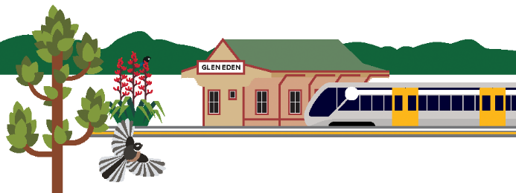
The Waitākere Ranges Local Board has been allocated $5.2 million for capital investment and $15.1 million for operational expenditure. A large part of this operational expenditure is committed to contract for maintaining our community facilities and open spaces. For a breakdown of current operational spend please see the supporting information.
The local board has been allocated additional funding in 2026/2027 under a new formula that better recognises the size of our service area, but it has been proposed that some of this additional funding for operational expenditure will be needed to address cost increases. As many of these increases are outside of our control due to rises in the cost of delivering existing services, such as utilities, asset maintenance and staffing requirements we will be seeking savings and changes in delivery but also advocating for the Governing Body to increase the allocation to cover these additional costs.
Taking into consideration indicative cost increases to existing services, the local board has an additional $400,000 for operational expenditure compared to current funding.

What we plan to deliver in 2026/2027
- Continue to deliver the local services, projects and programmes that are important to our community.
- Deliver additional investment in key areas, specifically:
- community wellbeing - continue to grow and evolve our programmes to support community wellbeing with a focus on tamariki and rangatahi, as well as older people
- review level of community grants, including investigating a Facility Partnership Fund to support community organisations to plan, develop or upgrade community facilities
- improve engagement with communities of need, schools and youth
- mobility scooter, walking and cycling connections, particularly through parks.

Key projects planned for 2026/2027
- continue to invest in environmental restoration programmes with a focus on the Waitākere Ranges Heritage Area and our waterways
- support the Waitākere Ranges Heritage Area Forum work programme, particularly community engagement
- deliver park development, including play and amenity improvements in Swanson, Te Henga and Titirangi
- deliver Parrs Park improvements, including sports field irrigation improvements to increase playing time availability; and upgrading the skatepark
- provide tree planting and shelter to provide shade and amenity in parks, as well as berm planting in streets with low tree cover
- review maintenance of local parks and facilities to ensure they are well maintained while looking for savings
- improving drainage in several Glen Eden parks to extend usable time.
- continue to support arts, culture and events programmes
- continue to invest in local climate action to increase resilience and decrease emissions.
For more information see section 1.19 of the Supporting Information.
Te Poari ā-Rohe o Waitematā

Waitematā Local Board

The Waitematā Local Board has been allocated $14.1 million for capital investment and $39.1 million for operational expenditure. A large part of this operational expenditure is committed to contracts for maintaining our community facilities and open spaces. For a breakdown of current operational spend, see the supporting information.
Through the Long-term Plan 2024-2034 the council moved to a new funding model for local boards. As a result, it is now the local board’s responsibility to address changes to the cost of delivering services. The local board is facing cost increases outside of our control due to unavoidable rises in the cost of delivering existing services, such as utilities, asset maintenance, staffing requirements as well as pressures on revenue. As a result, the local board may need to make difficult decisions to address these.
The indicative cost increase to deliver existing services is $1.0 million in operational expenditure. This indicative amount may change before the final Annual Plan decisions are made.

Changes to current service levels / fees and charges
To address the cost increases we are facing, the local board could make some or all of the following changes to service levels / fees and charges:
- reduce library hours:
  - Central City Library hours by 3 hours per week, e.g. closing on weekdays at 7pm
  - Little Leys Library hours by 5 hours per week, e.g. closing on weekdays at 5pm
  - Grey Lynn Library by 2.5 hours per week, e.g. closing on weekdays at 5pm
  - Parnell Library hours by 2.5 hours per week, e.g. closing on weekdays at 5.30pm
- reduce non-critical maintenance, such as bollard and post-and-rail maintenance, and cleaning of plaques and signs
- review and reduce mowing specifications on steep slopes and in some parks, and review traffic management plans for mowing and street garden maintenance
- delay non-essential tree work
- reduce community grant funding
- reduce accommodation grant funding to community groups, to help meet the costs associated with their premises
- increase adult swim fees at council pools by up to $3.
For more information see section 1.20 of the Supporting Information.
Te Poari ā-Rohe o Whau

Whau Local Board
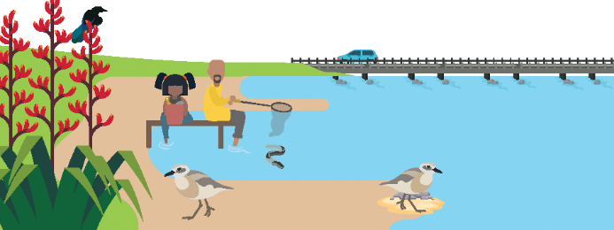
The Whau Local Board has been allocated $39.1 million for capital investment and $23.8 million for operational expenditure. A large part of this operational expenditure is committed to contracts for maintaining our community facilities and open spaces. For a breakdown of current operational spend please see the supporting information.
The local board has been allocated additional funding in 2026/2027, but some of this additional funding for operational expenditure will be needed to address cost increases outside of our control due to unavoidable rises in the cost of delivering existing services, such as utilities, asset maintenance, staffing requirements as well as pressures on revenue.
Taking into consideration indicative cost increases to existing services, the local board has an additional $0.3 million for operational expenditure compared to current funding.

What we are plan to deliver in 2026/2027
- continue to deliver the local services, projects and programmes that are important to our community
- deliver additional investment in key areas, specifically:
  - design and build a new destination playground at Avondale Central Reserve
  - promote community identity and diversity by funding a coordinator for Welcoming Communities, supporting the PAN African Hub, and refreshing the Whau Ethnic Peoples Plan
  - engage and respond to youth needs, and co-design initiatives to address opportunities and gaps
  - improve water quality and flood resilience of Whau streams and rivers through collaboration with volunteers, local schools, community hubs, organisations, and neighbouring local boards
  - prioritise projects identified through the Whau Sport & Recreation Facilities Plan and leverage partnerships to provide a local facility network for the community
  - develop a Local Parks Management Plan to guide decisions on managing use, development, and protection of all 146 parks, reserves and open space within the Whau.

Key projects planned for 2026/2027
- complete the construction of Te Hono, the new library and community centre in Avondale and prepare the space for community use
- secure land and progress the investigation and design of a new aquatic and recreation facility within the Whau Local Board area
- plan and design a local park in conjunction with the stormwater pond construction at the old Crown Lynn Pottery site
- improve coordination for community resilience and emergency preparedness across Whau hubs, houses, and other community spaces
- progress Whau heritage initiatives including to renew and provide interpretation for existing Pou and to install physical markers along the historic portage route that links the Waitematā and Manukau harbours.
For more information see section 1.21 of the Supporting Information.

Part 3
Ō reiti me ētahi atu tūemi

Your rates
Your rates pay for a wide range of day-to-day services and support investment in Auckland’s infrastructure that supports our growing region. The council remains committed to keeping rates affordable for the community.
Our Annual Plan 2026/2027 includes an overall rates increase of 7.9 per cent for the average-value residential property, or around $320 a year ($6.16 a week), in line with what we signalled in the LTP. The increase in rates is mainly due the $235 million yearly cost to run and own the council’s share of the City Rail Link, the bulk of which is interest and depreciation costs for the council's share of CRL. Although the overall rates increase is higher than we would like, our focus on savings and efficiency has helped keep the increase lower than what it could have been. Not everyone will have a 7.9 per cent rates increase. Rates vary based on the capital value of each property and the classification of a property (residential and business either urban or rural, and farm/lifestyle). Individual properties might also be subject to specific targeted rates which might impact the rates change. Our online rates guide provides estimated rates for each property.
The average rates increase includes:
- an average increase of 3.5 per cent to the Natural Environment Targeted Rate (NETR) and Climate Action Transport Targeted Rate (CATTR) for existing ratepayers, as set out in the LTP
- an increase from $14.04 to $16.59 (being $2.55 per year or 22 per cent for the average-value residential property) in the Water Quality Targeted Rate (WQTR), as provided for in the LTP
- a 2.2 per cent decrease to the overall Waste Management Targeted Rate for the typical household
- increase of 9.53 per cent to the general rate for existing ratepayers. General rates are paid by every property and fund a range of services available to all Aucklanders including libraries, pools and parks, roads and footpaths, stormwater services and public transport. The CRL will provide transport, economic and environmental benefits across the Auckland region.
- As the rating base in the business sector didn’t grow as fast as the non-business sector for 2025/2026, the total business rates (general rates and the WQTR, NETR, and CATTR) will need to increase a bit more in 2026/2027 than the 8.22 per cent forecast in the LTP to maintain their share. The LTP provided for business properties share of general rates and the WQTR, NETR, and CATTR to be 31 per cent. The overall rates increase for the average-value business property is forecast to be 9.84 per cent for 2026/2027.

Total rates change for 2026/2027
The analysis included in this section are subject to changes in property data over the remainder of the 2025/2026 financial year, in particular as a result of settlement of remaining revaluation objections. The council revalues properties every three years and that will not occur this year.
Proposed rates changes for residential and business property | Residential | Business
Average CV | $1,281,500 | $3,886,000
Total rates 2025/2026 | $4,054.96 | $22,423.38

Breakdown of changes to 2025/2026 rates
General rates increase | $323.48 | $2,171.91
Change to Water Quality Targeted Rate | $2.55 | $16.59
Change to Natural Environment Targeted Rate | $1.46 | $11.07
Change to Climate Action Transport Targeted Rate | $2.31 | $17.10
Change to Waste Management Minimum Base Service rate | -$3.71 | -$3.71
Change to Waste Management Standard Recycling rate | -$6.31 | -$6.31
Change to Waste Management Standard Refuse rate | $7.27 | Not applicable
Change to Waste Management Food Scraps rate | -$6.89 | Not applicable
Total rates 2026/2027 | $4,375.12 | $24,630.03
Annual change | $320.16 | $2,206.65
Weekly change | $6.16 | $42.44
Annual change per cent | 7.90% | 9.84%

Estimated increases for residential ratepayers 2026/2027
CV | Current rates | New rates | Change | % Change | Change weekly
500,000 | $2,218 | $2,372 | $154 | 7.0% | $2.97
750,000 | $2,806 | $3,013 | $207 | 7.4% | $3.99
1,050,000 median | $3,511 | $3,782 | $271 | 7.7% | $5.21
1,281,500 average | $4,055 | $4,375 | $320 | 7.9% | $6.16
1,500,000 | $4,569 | $4,935 | $366 | 8.0% | $7.05
2,000,000 | $5,744 | $6,216 | $473 | 8.2% | $9.09
3,000,000 | $8,095 | $8,779 | $685 | 8.5% | $13.17

Estimated increases for business ratepayers 2026/2027
CV | Current rates | New rates | Change | % Change | Change weekly
500,000 | $3,555 | $3,880 | $326 | 9.2% | $6.26
750,000 | $4,948 | $5,412 | $465 | 9.4% | $8.93
1,050,000 median | $6,620 | $7,251 | $631 | 9.5% | $12.14
1,500,000 | 9,127 | 10,008 | 881 | 9.7% | 16.95
2,000,000 | 11,913 | 13,072 | 1,159 | 9.7% | 22.29
3,886,000 | 22,423 | 24,630 | 2,207 | 9.8% | 42.44
10,000,000 | 56,494 | 62,097 | 5,603 | 9.9% | 107.75
Online rates guide
Our online rates guide provides estimated rates for each property.
aucklandcouncil.govt.nz/ratesguide
For further information on the calculation of rates, including farm rates, please refer to the Supporting Information for this Consultation Document, page 112.

Notes to the rates increase analysis presented in this section
- The indicative rates shown in the table and graphics in this section include general rates, the Water Quality Targeted Rate, the Natural Environment Targeted Rate, the Climate Action Transport Targeted Rate, the Waste Management Minimum Base Service Rate, the Standard Recycling Rate, the Standard Refuse Rate (included for residential properties only), and the Food Scraps Rate (included for residential properties only). Targeted rates that are not applied on a region-wide basis are excluded from this analysis.
- We have not included the Refuse Targeted Rate for business properties as it only applies to some business properties in the former Auckland City Council area.
- The rates shown in this analysis do not include water or wastewater charges which are set by Watercare. Watercare’s latest Price Quality Path Report states that its combined water and wastewater tariffs will not increase by more than 7.2 per cent for 2026/2027.
- The rates numbers included in this document are based on property information held by the council as of November 2025 and cost information (including inflation assumptions) available at the time the consultation materials were developed. They are subject to change.
- The final rates will be adopted in June 2026 after taking into consideration the feedback received during consultation and any cost changes since consultation including more up-to-date forecasts on inflation.
- The estimated rates increases for the average-value residential property included in this document are based on like-for-like waste management services between years. Specifically, the analysis assumes that the average-value residential property is paying the full standard refuse targeted rates in any given year. This ensures that the rates increases shown exclude, to the extent possible, any movement in cost due to a change in service level.
- Properties in Rodney will be charged for a full 12 months of rubbish collection in 2026/2027, compared with only for the 10 months they received the service in 2025/2026. This will be reflected in their overall rates change.

Other changes to rates
The future of the Waitākere Rural Sewerage Scheme and associated targeted rate
Around 3,300 properties in the Waitākere Ranges Local Board area pay an annual targeted rate for council-organised septic tank pump-outs once every three years under the Waitākere Rural Sewerage Scheme. The primary objective of the scheme, the minimisation of contamination risks septic tanks pose to waterways, can now be achieved more effectively through the Safe Septic Programme. The overlap between the two schemes creates confusion for property owners.
We're now consulting with you on the future of the scheme. The current service contract for the three yearly pump-out expires on 30 June 2027. To allow time for the procurement process if the scheme is to continue, we will need to decide whether to retain the scheme by June 2026.
We are consulting on two options for the future of the scheme. Under both options, property owners will continue to be legally required to have tanks pumped out:
- end the scheme and associated targeted rate on 30 June 2027 (being the end of the currently contracted three-year service cycle), allowing property owners to arrange private pump-outs, likely at lower cost for most.
- retain the scheme and associated targeted rate, which would require a higher targeted rate from the 2027/2028 financial year onwards (indicative amount $430–$520 annually reflecting higher Watercare disposal costs and higher operating costs; exact amount to be consulted on as part of LTP 2027-2037 if scheme is to be retained).
Consultation feedback will inform our final decision in June 2026. The targeted rate for 2026/2027 remains unchanged at $336.80 per year.
For more information, please see pages 115-116 of the Supporting information.

Proposed new local services targeted rates for Mangere-Otahuhu Local Board and Otara-Papatoetoe Local Board
We are proposing to introduce the Mangere-Otāhuhu Local Services Targeted Rate and the Ōtara-Papatoetoe Local Services Targeted Rate to fund local services in those local board areas. Rising operating costs have led to a situation where the currently allocated funding for these boards is no longer adequate to cover the costs of the previously planned activity and services. The proposed new targeted rates will provide the necessary funding to maintain services in these local board areas. Other options, such as increased fees or reducing costs through changes to some services, are also being considered.
The proposed rates are:
- Māngere-Ōtāhuhu Local Services Targeted Rate of $47.11 (GST inclusive) per Separately Used or Inhabited Part per annum, on all rateable land except land categorised as zero-rated in the Māngere-Ōtāhuhu Local Board area to fund $1,050,000 of local activities in the Māngere-Ōtāhuhu Local Board
- Ōtara-Papatoetoe Local Services Targeted Rate set on capital value, using the general rate differential categories and ratios set out in the Funding Impact Statement, on all rateable land in the Ōtara-Papatoetoe Local Board area, to fund $1,100,000 of local activities in the Ōtara-Papatoetoe Local board. The rate would be $27.14 for the average-value residential property in the local board area.
For more information, please see pages 117-126 of the Supporting information.

Further proposed rates changes
We also propose to:
- reduce the area of the Onehunga Business Improvement District (BID) and the associated targeted rate requirement
- extend the Kingsland BID and the associated targeted rate
- reduce the Rodney Drainage District Targeted Rate for properties in the Te Arai Drainage District, at the request of Te Arai Drainage Board Incorporated.
For more information, please see pages 127 of the Supporting information.

Changes to fees and charges
In addition to most fees and charges which we are adjusting in line with inflation, we propose specific changes to the following fees:
- introduction of a $40 fee for swaps between refuse bins and bag packs, including swaps between different bag pack capacities
- residential parking permit operated by Auckland Transport
- some pool and leisure facilities fees
- an average 3% increase to hourly rates for building control and resource consent services.
For more information, please see pages 128-139 of the Supporting information.

Tūpuna Maunga Authority Operational Plan

The Ngā Mana Whenua o Tāmaki Makaurau Collective Redress Act 2014 (the Act) came into effect on 31 July 2014. The Act vested the Crown-owned land in 14 Tūpuna Maunga (ancestral mountains) in 13 iwi/hapū with interests in Auckland (Ngā Mana Whenua o Tāmaki Makaurau). The Act also established the Tūpuna Maunga o Tāmaki Makaurau Authority (an independent statutory board comprising the council and Ngā Mana Whenua) to administer the Tūpuna Maunga.
The Act requires that the Tūpuna Maunga Authority prepare an Annual Operational Plan to provide a framework in which the council must carry out the routine management of the 14 Tūpuna Maunga, under the direction of the Tūpuna Maunga Authority. This must be prepared and adopted concurrently with the council’s annual plan and included in a summary form.
For more information, see Section four of the Supporting information.
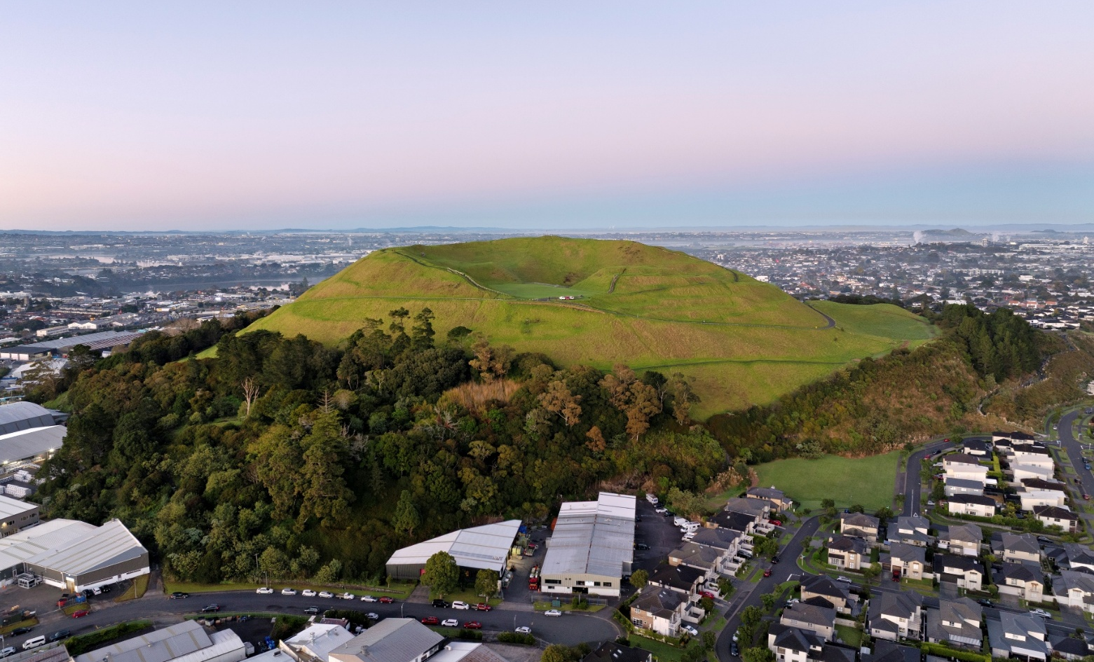
Photo of Maungarei | Mount Wellington
Part 4
He ara hei whakaputa i ō kōrero

How to have your say

Our plan 2026/2027
Our proposed Annual Plan 2026/2027 focuses on getting on with year three of our Long-term Plan (LTP) 2024-2034. It continues to progress the financial and physical resilience committed to in our LTP, while building a more efficient council focused on value for money for Aucklanders.
The plan builds on great progress in the second year of the long-term plan. (see page 7)
For 2026/2027 this means prioritising investment in transport and delivering on the reform of transport governance in Auckland, along with improving infrastructure, urban regeneration, development and property management, and continuing to enable local boards to deliver for their communities.
A major highlight of this year’s plan is the expected start of the City Rail Link (CRL), which will transform Auckland when it launches in the second half of 2026.
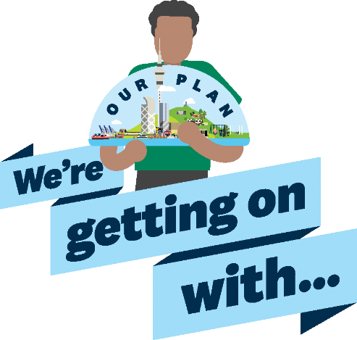
Key programmes across seven investment areas (see page 10)
Delivering our vision (see page 6)
City Rail Link- main reason for rates rise (see page 14)
Funding local services and infrastructure (see page 19)
A 7.9% rates rise for average value residential properties due mainly to CRL costs (see page 14)
Getting the most out of every dollar (see page 16)
Have your say (see page 54)

Give us your views on our proposed Annual Plan
There are a number of ways you can share your views with us on the Annual Plan 2026/2027. Please take the time to get involved.
Written and online feedback
- You can provide feedback online at akhaveyoursay.nz/ourplan
- Complete the feedback form included in this Consultation Document
- Request documents at council libraries and local board offices and then send it back to the freepost address: Annual Plan, Auckland Council, Freepost Authority 182382, Private Bag 92300, Auckland 1142
- Download a copy online and send it to the freepost address provided.

Face-to-face
Face-to-face events will take place across the region where you can provide feedback in person. The details of these events will be published on the website at akhaveyoursay.nz/ourplan or you can call
for more information on 09 301 0101.

Social media
You can find out more on the following social media channels:
- Facebook
- Instagram
- LinkedIn.

Webinars
We'll hold online webinars, where subject-matter experts will be discussing and providing information on the annual plan. You will have an opportunity to listen and ask questions.
For more information and to register for these webinars go online to akhaveyoursay.nz/ourplan.

Translations
We want as many people as possible from Auckland’s communities to have their say in this process. To help with this, translated summaries of this consultation document as well as the feedback form are available in te reo Māori, Korean, simplified Chinese, traditional Chinese, Samoan, Tongan, New Zealand Sign Language video, Hindi and Easy Read.
The translated documents are available:
- online at akhaveyoursay/ourplan for downloadable translations and feedback forms
- on request in libraries and service centres
- by emailing akhaveyoursay@aucklandcouncil.govt.nz
- by calling 09 301 0101.

Māori engagement
As well as this consultation document, Auckland Council engages with Māori including the Iwi governance and operational collectives, Tāmaki Makaurau - Mana Whenua Forum - Governance Forum, Ngā Pou o te Whenua - Mana Whenua Forum - Governance Forum (6 iwi), Auckland Development Office - Mana Whenua Forum - Governance/Operational and Interim Mana Whenua Forum - Operational Forum on regional matters and mātāwaka entities to support their involvement in decision-making and community engagement.

Where to find more information:
You can find everything you need to know at akhaveyoursay.nz/ourplan including the Supporting Information, an online feedback form and a schedule for Have Your Say events. The full Supporting Information that supports this Consultation Document will be available at libraries, council service locations and local board offices. If none of the above methods are suitable for you, please call us on 09 301 0101 to discuss alternative options.

Annual Plan 2026/2027 have your say
You can give feedback until 11.59pm on Sunday 29 March 2026.
We recommend you read the consultation document before you leave feedback.
Visit akhaveyoursay.nz/ourplan or any council library for a copy of the document.
We encourage you to give feedback online at akhaveyoursay.nz, or you can:

Scan and email your completed form to:
akhaveyoursay@aucklandcouncil.govt.nz
Post your completed form to:
Annual Plan 2026/2027
Auckland Council
Private Bag 92300, Victoria Street West
Auckland, 1142.

Feedback form

Your details
Your name and feedback will be included in public documents. No other personal details will made available to the public.
First name:

Last name:

Email or postal address:

Your local board or suburb:

Please choose the option that applies to you.
The feedback I am giving is:
☐ my personal feedback
☐ feedback as the official representative of an organisation
Organisation name:

These optional questions help us understand who is engaging with us.
Which gender are you?

☐ Male
☐ Female
☐ Another gender:

What is your age group?

☐ Under 15
☐ 15-17
☐ 18-24
☐ 25-34
☐ 35-44
☐ 45-54
☐ 55-64
☐ 65-74
☐ 75+

Which ethnic group(s) do you feel you belong to? (Please select as many as apply)

☐Pākehā/NZ European
☐ Māori
☐ Cook Islands Māori
☐ Samoan
☐ Tongan
☐ Indian
☐ Chinese
☐ Filipino
☐ Korean
☐ Other (please specify):

Important privacy information
The personal information that you provide in this form will be held and protected by Auckland Council in accordance with our privacy policy (available at aucklandcouncil.govt.nz/privacy and with the Privacy Act 2020. The privacy policy explains how we can use and share your personal information in relation to any interaction you have with the council, and how you can access and correct that information. You should familiarise yourself with this policy before submitting this form.

Your feedback
(All questions are optional – you can answer all or any)

Question 1: Our overall plan and proposed rates increases
Our Annual Plan 2026/2027 builds on the first two years of our Long-term Plan 2024-2034 (LTP). It focuses on continuing to strengthen our finances and Auckland’s physical resilience, while investing where it is needed most to meet the needs of our growing communities.
In 2026/2027 that includes prioritising investment in:
- transport
- water
- helping local boards respond to the needs of their communities.
This annual plan also proposes how we will pay for services and investments, including a 7.9 per cent rates increase for an average-value residential property. The increase in rates is mainly due to the $235 million yearly cost to run and own the City Rail Link, the bulk of which is interest and depreciation costs for the council’s share of CRL.
Individual rates increases will vary by property type and value. Use our online rates guide to see your property.
What do you think of the proposed annual plan?

☐ Support all
☐ Support most
☐ Do not support most
☐ Do not support any
☐ I don’t know

Tell us why

Question 2: Changes to other rates, fees and charges
Besides the 7.9 per cent rates increase for an average-value residential property, the annual plan includes changes to a range of other rates, fees and charges. These include introduction of a refuse bin/bag exchange fee, changes to the Kingsland and Onehunga BID programme areas, Waitākere Rural Sewerage Scheme, and an Auckland Transport proposal to increase residential parking permit fees in specific areas. Refer to pages 45-49 of the consultation document for information about proposed changes to rates, fees and charges.
What do you think about these proposed changes? (Please let us know the specific changes to
other rates, fees and charges you are commenting on)
Tell us why

Question 3: Local board priorities
For more information, read pages 45-49 of the consultation document.
You can find your local board on the Auckland Council website
3A. Which local board does your feedback relate to?

3B. What do you think of the options for your local board area in 2026/2027?

☐ Support all
☐ Support most
☐ Do not support most
☐ Do not support any
☐ I don’t know

Tell us why

Question 4: Other feedback
Do you have any other comments on the Annual Plan 2026/2027?
Including the Tūpuna Maunga Authority Operational Plan 2026/2027 (page 50 of the consultation document)?

Looking further ahead / shaping Auckland’s longer-term future
Now we want your feedback on longer-term priorities that will help shape the city over time.
We are planning some discussions for next year to inform plans and strategies to shape Auckland’s future. These include (but aren’t limited to):
- regional transport plans
- water service strategies
- Auckland’s spatial plan
- our 2027–2037 Long-term Plan, which sets funding for regional and local priorities listed below.
- We will continue to invest and deliver in all our investment areas, but we want to understand your priorities.

Question 5: Which areas are most important to you over the long term? Please rank these areas from 1 (most important) to 6 (least important)
☐ Economic development and events – growing Auckland’s economy and supporting events, tourism and creative industries.
☐ Local parks, community and recreation services – local parks, sports fields and other physical recreation services, libraries, community centres and services, and funding community-led initiatives.
☐ Planning and infrastructure to manage growth – planning how and where Auckland grows, rebuilding urban centres, improving infrastructure, and coordinating land-use with public services.
☐ Regional parks and environment – looking after Auckland’s natural areas, streams, coastal zones and cultural heritage, reducing waste, and supporting community-led environmental projects.
☐ Transport – roads, public transport, walking and cycling, and making it easier, safer and more sustainable for people to move around.
☐ Flood resilience – reducing flood risks, upgrading stormwater systems and protecting waterways.
What specific council activities or services do you most want us to prioritise, and why?

Question 6: City centre
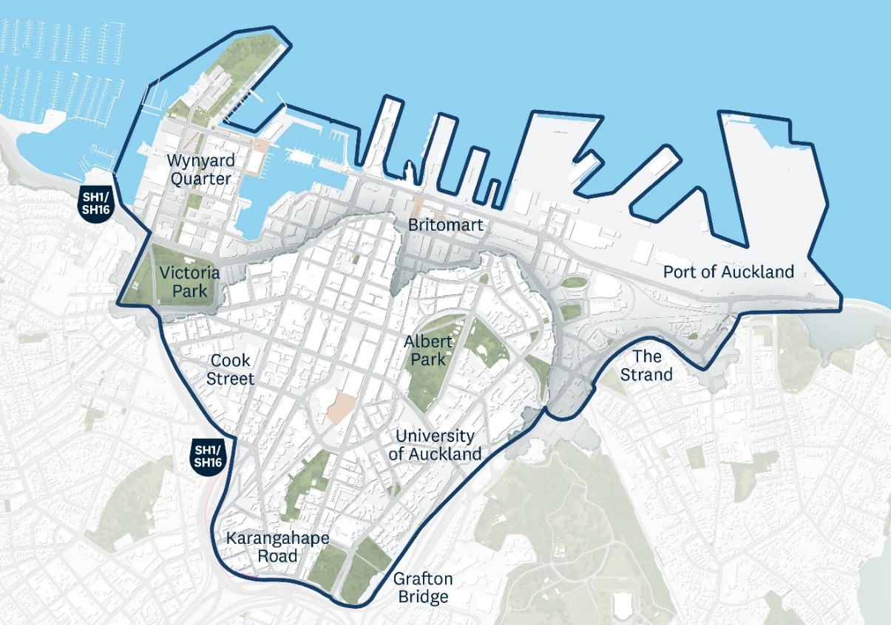
Auckland’s City Centre is the economic heart of our region. Overall, the city centre accounts for about a fifth of everything produced in Auckland’s economy. We want to make public spaces work better for people, get more value from major investments in transport, and make sure council helps the city centre thrive as a place to live, work, study, and visit.
What improvements do you think we should prioritise in the city centre? (Select up to 4)
☐ Better connections – improve links between the city centre, the waterfront and nearby neighbourhoods.
☐ Events and city life – attract people to the city centre through events, culture and a strong sense of place.
☐ Getting around – make it easier to walk, drive, cycle and use public transport in the city centre and from east to west, including better traffic flow.
☐ Māori identity and culture – reflect and celebrate Māori identity and culture throughout the city centre.
☐ Safety – a safer and more welcoming city centre, both day and night, for residents, workers and visitors.
☐ Streets and public spaces – improve streets, parks and public spaces so the city centre is a great place to live and spend time in.
☐ Supporting businesses – help businesses succeed by making them easier to access and attract more visitors to the city with well-designed streets and public spaces.
☐ Other (please specify):
Have more to say? You can attach extra pages.
Auckland Council Annual Plan 2026/2027 Consultation Document
© 2026 Auckland Council, New Zealand February 2026
Auckland Council disclaims any liability whatsoever in connection with any action taken in reliance of this document for any error, deficiency, flaw, or omission contained in it.
This document is licensed for re-use under the Creative Commons Attribution 4.0 International licence.
In summary, you are free to copy, distribute and adapt the material, as long as you attribute it to Auckland Council and abide by the other licence terms.



