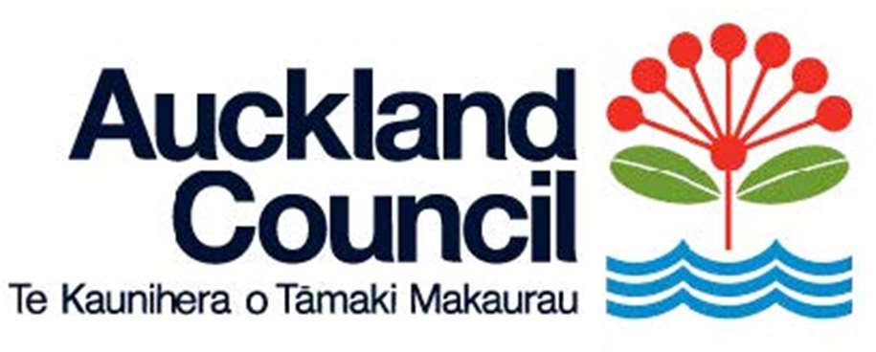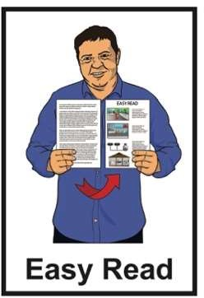

Summary of the Auckland Council Annual Plan

2026 / 2027

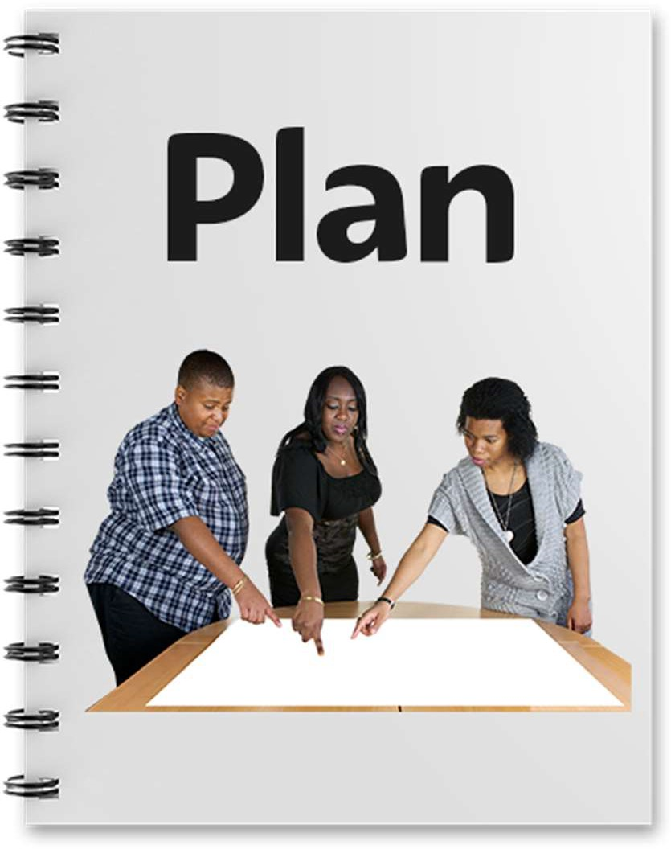

Published: February 2026

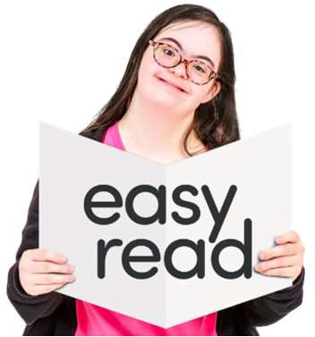
Page number:
What you will find in here

About this Easy Read 2

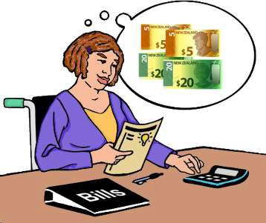
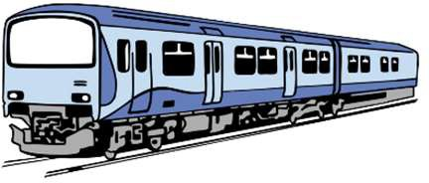
The main things we will do 7

Changes to rates 11

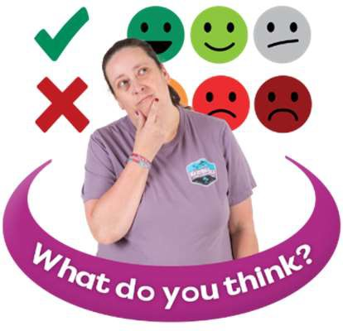
The future 13

Tell us what you think 15

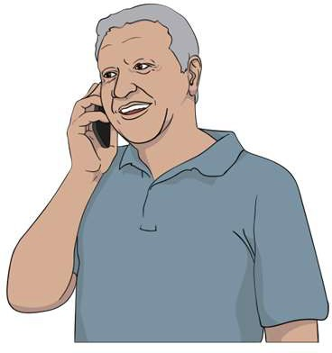
Contact us 18

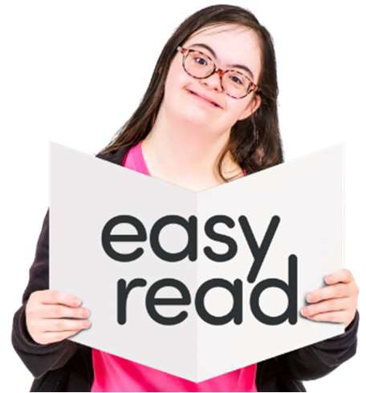
This Easy Read is a summary of the Auckland Council Annual Plan 2026/2027.
About this Easy Read

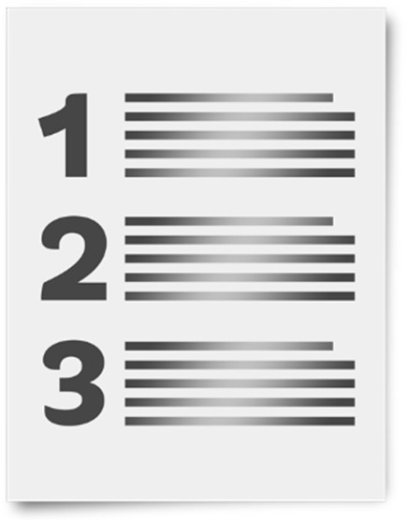
Here a summary:

- is shorter than the full Annual Plan

- tells you the main ideas in the Annual Plan.

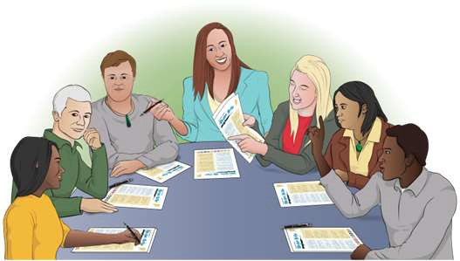
Auckland Council is the group of people who make choices about
how to run Auckland.


When you see the words
we / our / us in this Easy Read they mean Auckland Council.

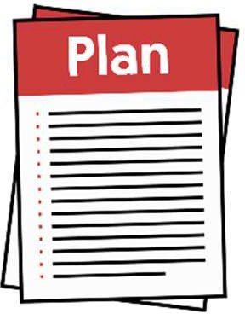
An Annual Plan is a document that
says what we will do each year.

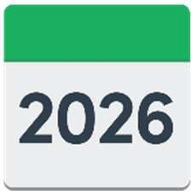
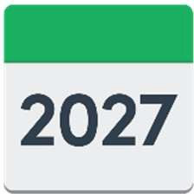

The Annual Plan 2026/2027 says what we will do from 2026 to 2027.

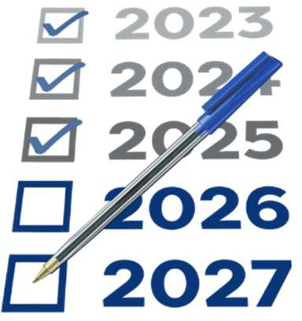
When you see the words this year
in this Easy Read they mean 2026 to 2027.

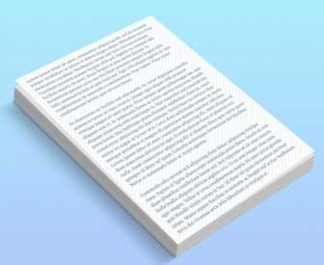
We also have a Long-term Plan 2024–2034.


The Long-term Plan 2024–2034
says what we are working on from 2024 to 2034.

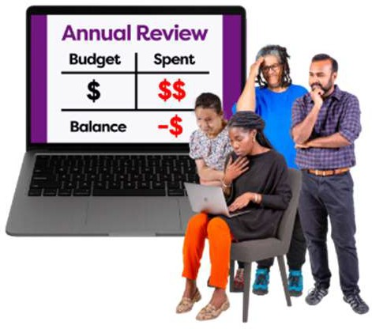
The Long-term Plan 2024–2034 says we need to manage our money well.

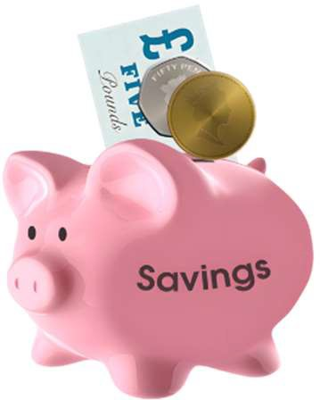
Managing our money well means:

- we have enough money to pay for things if something bad happens

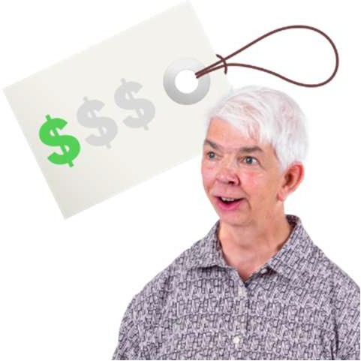
- services are:

  - run well

  - affordable.

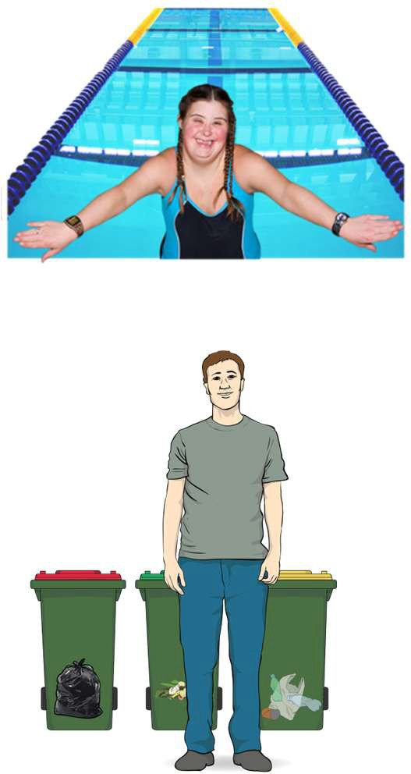
Here services are the things we provide like:

- pools

- buses

- rubbish collection.

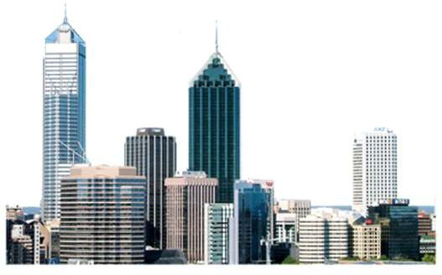
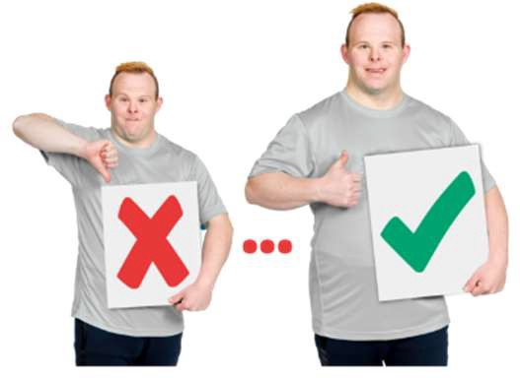
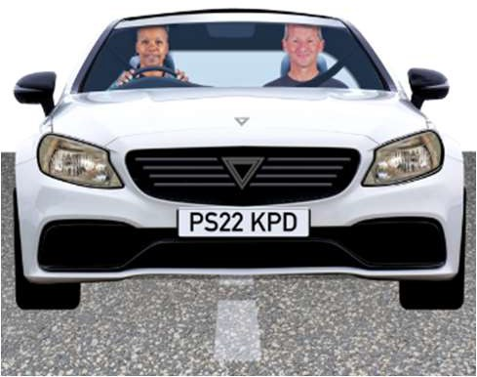
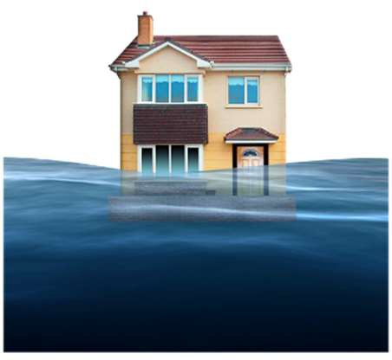
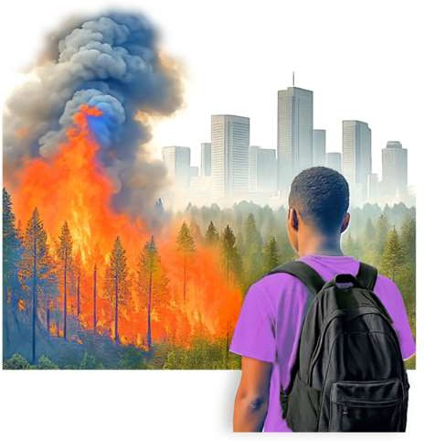
The Long-term Plan 2024–2034 also says we need to make the physical resilience of Auckland better.
Physical resilience means what happens to these things when something bad happens.

For example if a road always floods when there is a storm we need to
make the physical resilience of the road better.
Here physical means all the things people have built in Auckland like:

- roads

- pipes

- buildings.

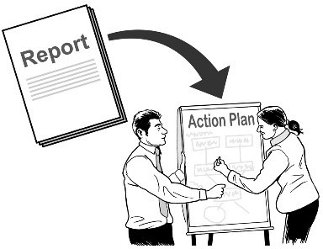
The Annual Plan 2026/2027 says what we need to do this year to make the things in the Long-term Plan 2024–2034 happen.

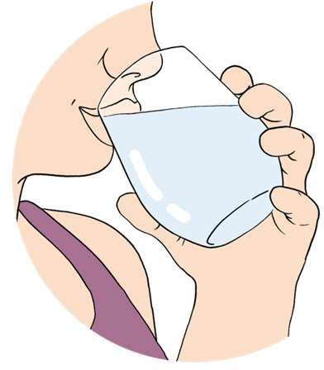


This year we will focus on spending money on:
The main things we will do

water

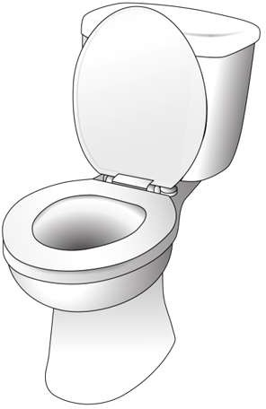
- transport.
Here spending money on water means spending money on things like:

- sewage pipes like the pipes from your toilet
- making sure everyone has clean drinking water.

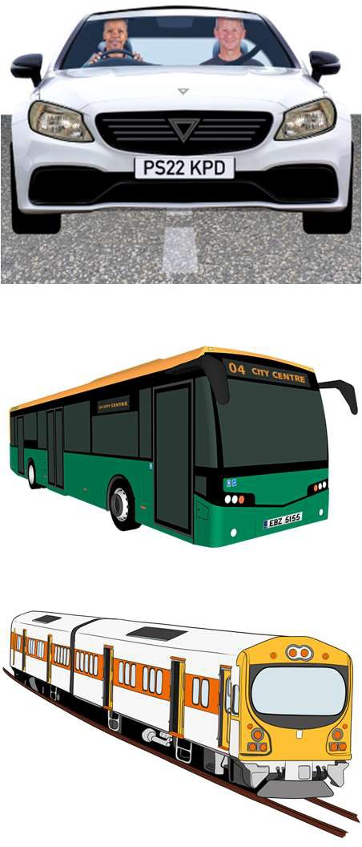
Here communities means all the
people who live in each part of Auckland.
Here spending money on transport means spending money on things like:

- roads

- buses

- trains.

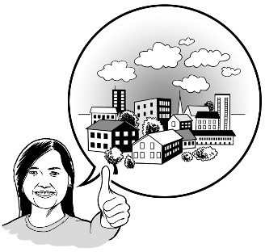
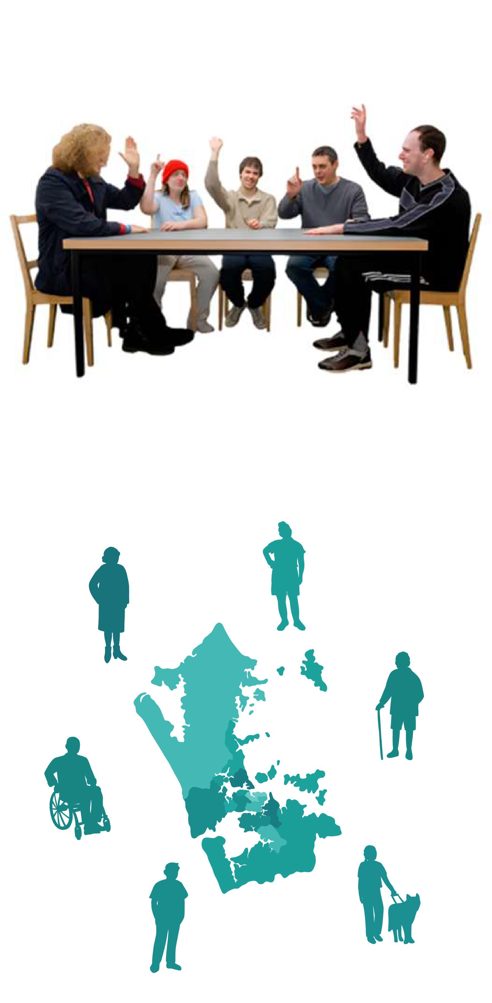
We will also support local boards to do the things people in their communities want.
Local boards are groups of people who make choices about how to run things in their part of Auckland.

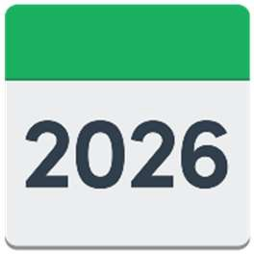
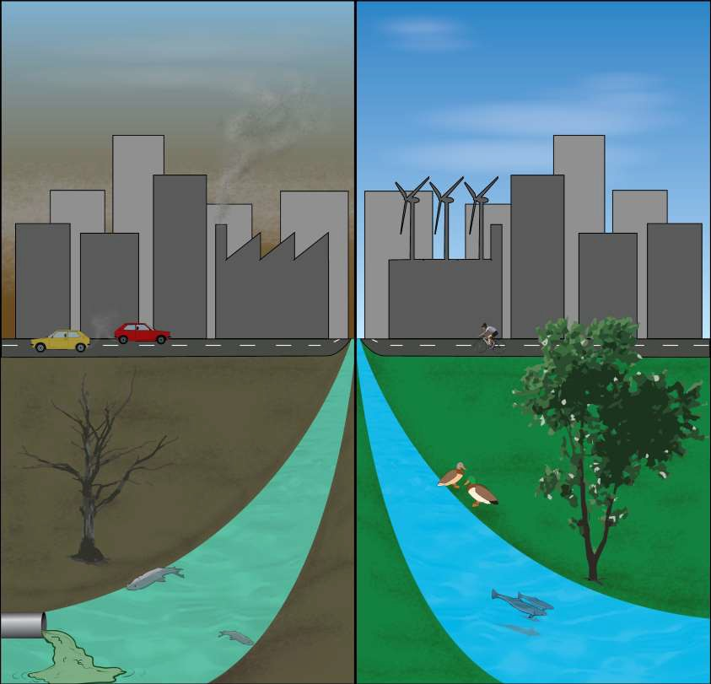
The City Rail Link will open this year.

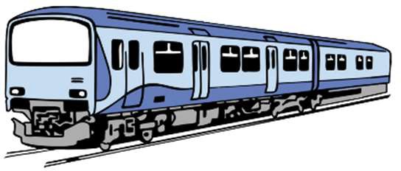
The City Rail Link is a new tunnel for trains underneath Auckland.

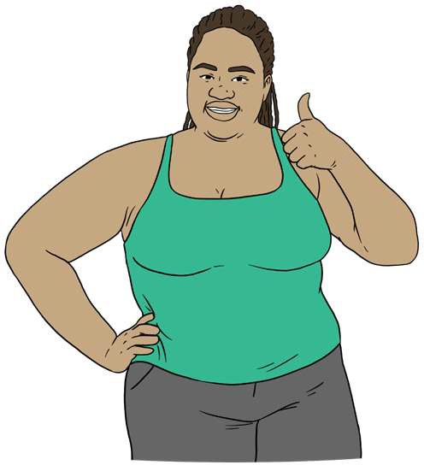
It will make it easier to travel around Auckland by train.

It will be better for the environment
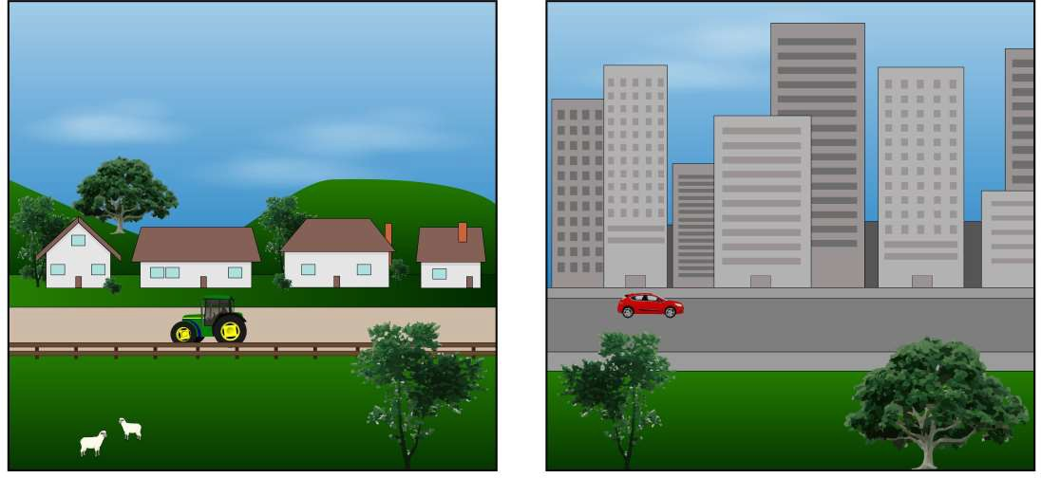
than travelling by car.
The environment is everything around us like the:

- air

- ground

- trees.


This year we are going to spend nearly 4 billion dollars on things like:

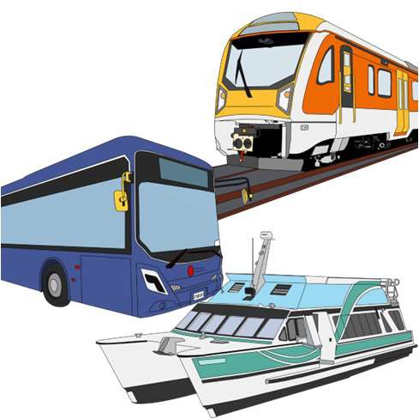
- roads

- public transport like:

  - buses

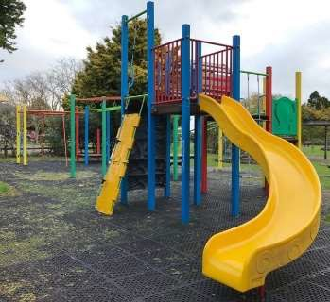
  - trains

- parks

- community facilities like:

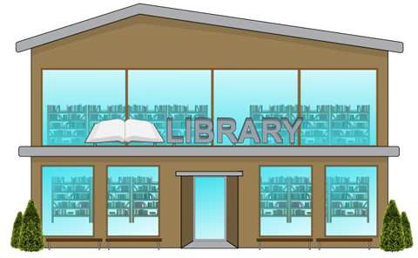
  - libraries

  - pools.

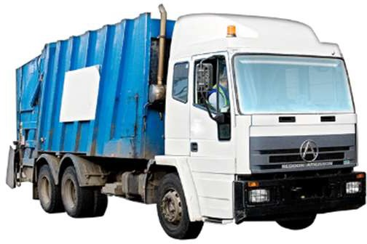
We will also spend over 5 billion dollars on services Aucklanders use every day like rubbish collection.

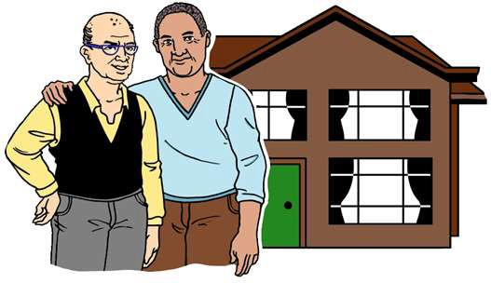

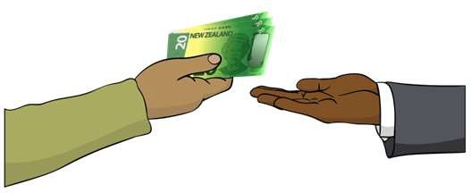
We think rates need to go up by nearly 8 percent this year.
Rates are the money Aucklanders pay us so we can run services for Aucklanders.

You only have to pay us rates if you own your home.
Changes to rates

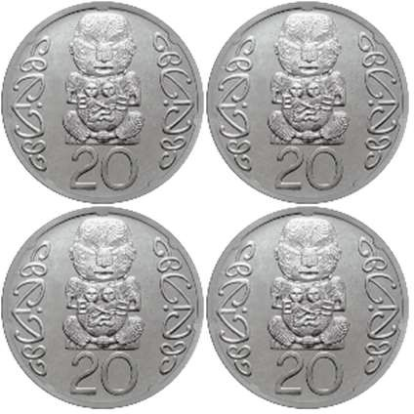
Rates going up by nearly 8 percent means you will pay about 80 more cents for every 10 dollars you spend on rates.

The Long-term Plan 2024–2034 also said rates would need to go up by nearly 8 percent this year.

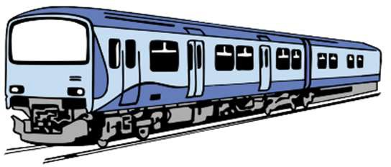
Rates are mostly going up to pay for running the City Rail Link.

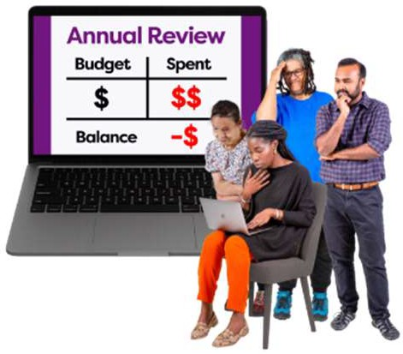
The rates need to go up by more than we wanted them to.

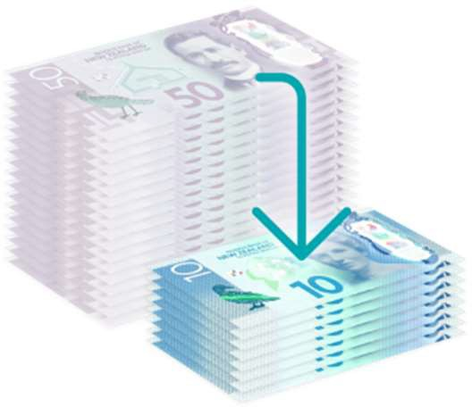
We are doing things to save money.

If we did not do these things the rates would have to go up by more than
8 percent.

This year we need to make lots of decisions about things that will affect Auckland in the future.
The future

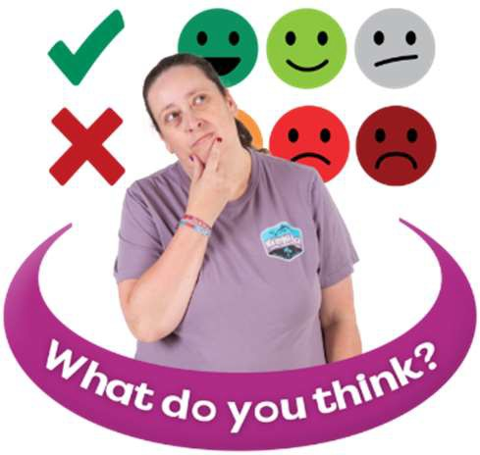
To support us to make these decisions we want to know what you think is important for the future.


We also want to know what you think the city centre of Auckland should be like in the future.

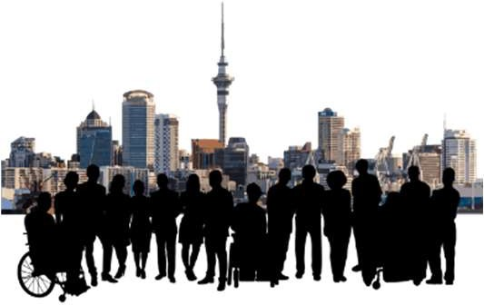
The city centre is a very important part of Auckland.


The city centre earns a lot of money for Auckland.

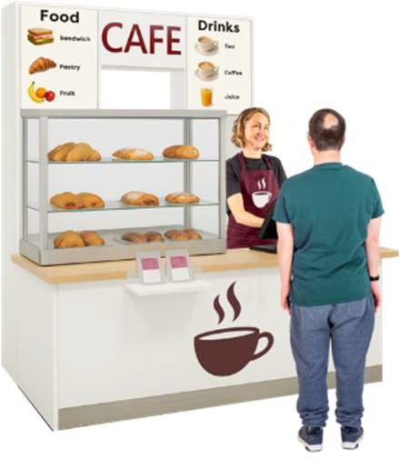
The things we decide now will affect what things are like in the city centre in the future like what:

- kinds of:

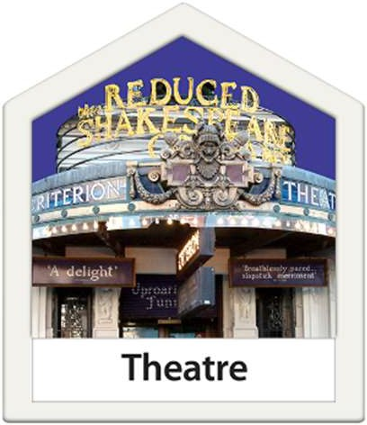
  - jobs there are

  - businesses there are

- there is to do for fun

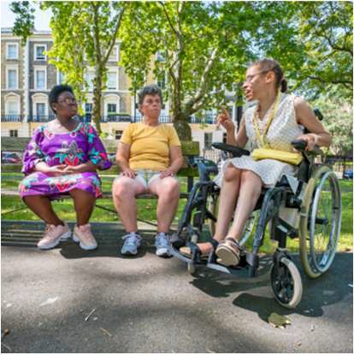
- it is like to live there.

We want to make sure people like being in the city centre.

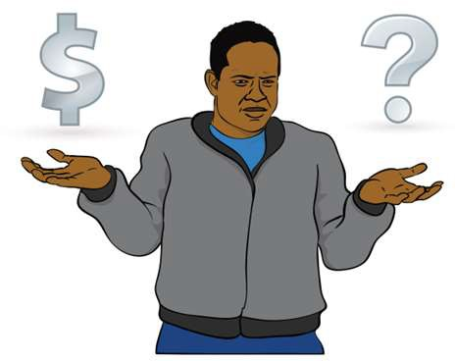
We also want to make sure the money we spend on making public transport in the city better is worth it.

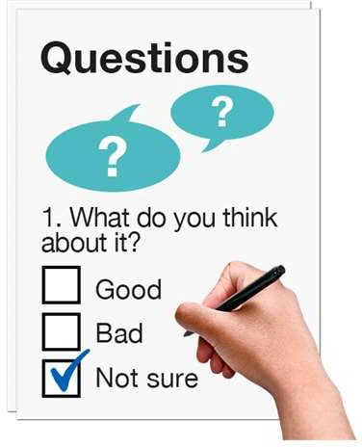
We want to hear what you think about the Annual Plan 2026/2027.
Tell us what you think


You can visit this website to tell us what you think:

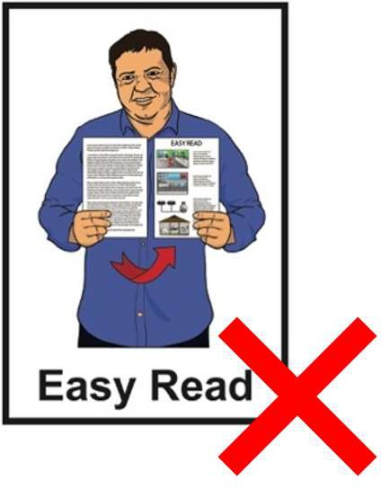
www.akhaveyoursay.nz/ourplan

This website is not in Easy Read.

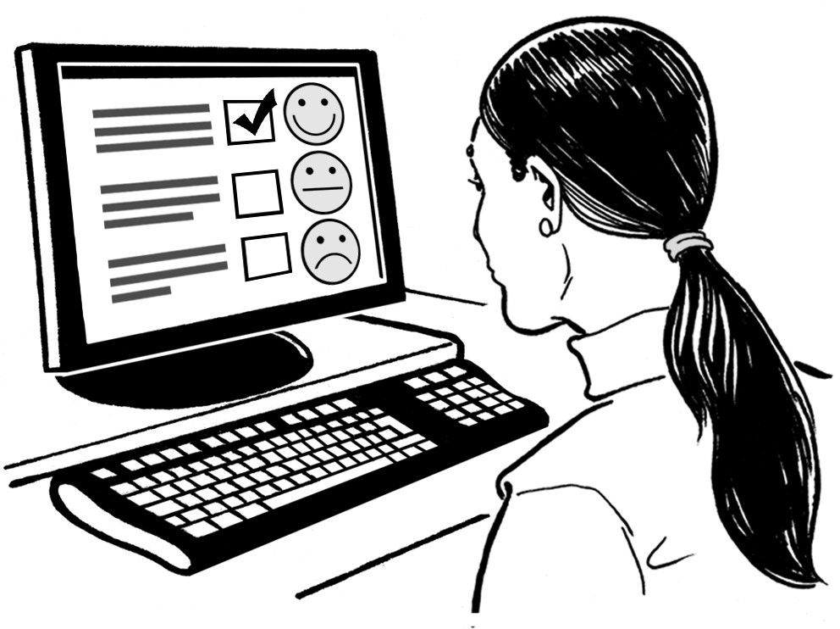
You can use an Easy Read form to tell us what you think.

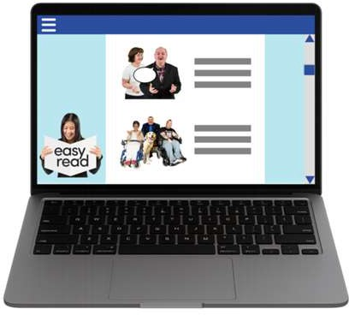
You can find the Easy Read form at:

www.akhaveyoursay.nz/ourplan

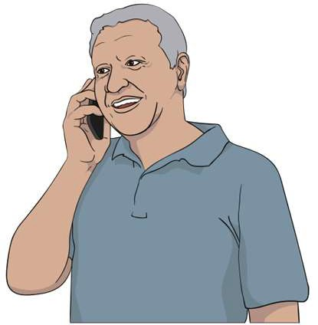
You can phone us to tell us what you think on:

09 301 0101

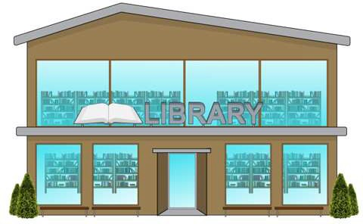
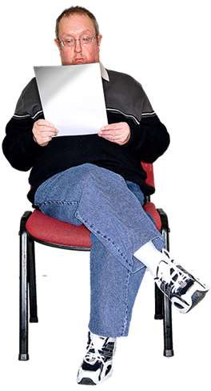
You can visit a library to tell us what you think.

You should read the consultation document before telling us what you think.
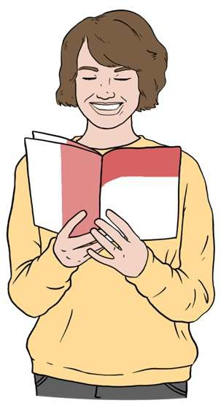
The consultation document tells
you more information about the Annual Plan 2026/2027.

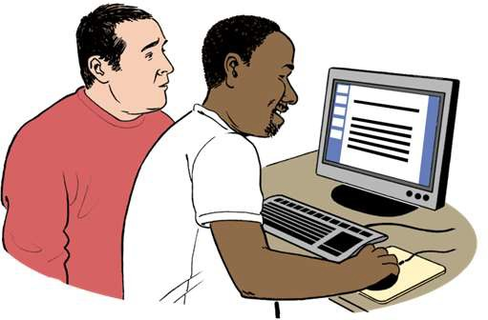
You can find the consultation document at:

www.akhaveyoursay.nz/ourplan

The full consultation document is not
in Easy Read.

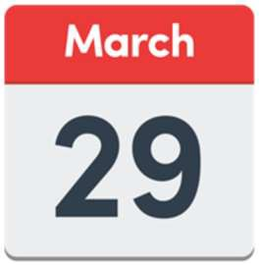
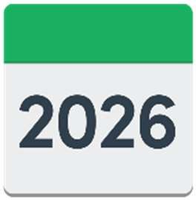
You need to tell us what you think by
Sunday 29 March 2026.

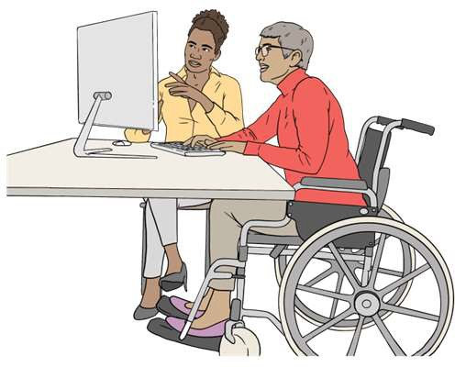
We might make changes to the Annual Plan 2026/2027 once we hear what people think.

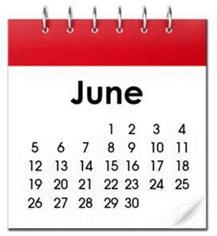
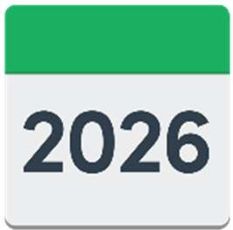
The finished Annual Plan 2026/2027 will be ready by June 2026.

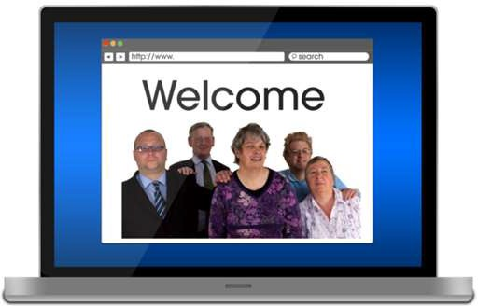
You will be able to see it on our

website:

www.aucklandcouncil.govt.nz

This website is not in Easy Read.


You can contact us if you have questions about the information in this Easy Read.
Contact us

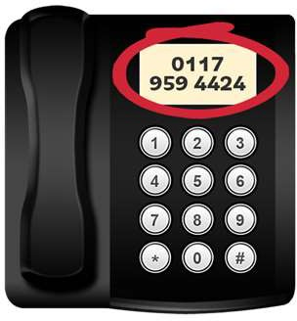
You can phone us on:

09 301 0101

You can write us a letter at:

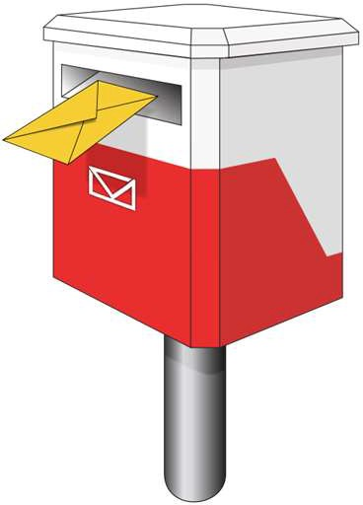
Auckland Council Private Bag 92300 Victoria Street West Auckland 1142


You can find other ways to contact us on our website:

www.aucklandcouncil.govt.nz/contactus

This website is not in Easy Read.


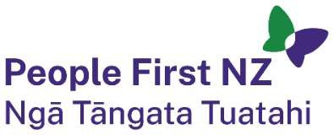
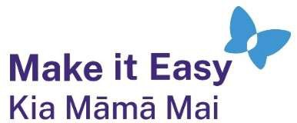
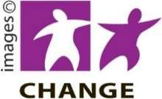





This information has been written by Auckland Council.

It has been translated into Easy Read by the Make it Easy Kia Māmā Mai service of People First New Zealand Ngā Tāngata Tuatahi.

The ideas in this document are not the ideas of People First New Zealand Ngā Tāngata Tuatahi.

All images used in this Easy Read document are subject to copyright rules and cannot be used without permission.

Make it Easy uses images from:

- Photosymbols
- Change Images
- Huriana Kopeke-Te Aho
- SGC Image Works
- T Wood
- Studio Rebeko
- Inga Kramer.

