
How to have your say
He ara hei whakaputa i ō kōrero
Auckland Council Annual Plan 2026/2027 Consultation Document
Part Four: Have Your Say

Adapted in 2026 by Accessible Formats Service,
Blind Low Vision NZ, Auckland
Total print pages: 34-39
Total large print pages: 18
Transcriber's Note: The logo at the top of the page is AK have your say.

Notes for the Large Print Reader
Print page numbers are indicated as:
Page 1
Main text is in Arial typeface, 18 point.
Headings are indicated as:

Heading 1

Heading 2

Heading 3

Heading 4

Transcriber's Note
This Large print edition contains print pages 34 to 39. All page number references in this braille document refer to the original print page numbers.

Page 34

How to have your say

Our plan 2026/2027
Our proposed Annual Plan 2026/2027 focuses on getting on with year three of our Long-term Plan (LTP) 2024-2034. It continues to progress the financial and physical resilience committed to in our LTP, while building a more efficient council focused on value for money for Aucklanders.
The plan builds on great progress in the second year of the long-term plan. (see print page 5)
For 2026/2027 this means prioritising investment in transport and delivering on the reform of transport governance in Auckland, along with improving infrastructure, urban regeneration, development and property management, and continuing to enable local boards to deliver for their communities.
A major highlight of this year's plan is the expected start of the City Rail Link (CRL), which will transform Auckland when it launches in the second half of 2026.

We're getting on with …
- Delivering our vision (see print page 5)
- Key programmes across seven investment areas (see print page 8)
- City Rail Link (see print page 12)
- Funding local services and infrastructure (see print page 15)
- Getting the most out of every dollar (see print page 13)
- Your rates—a 7.9% rates increase for average-value residential properties (see print page 30)
Page 35

Give us your views on our proposed Annual Plan
There are a number of ways you can share your views with us on the Annual Plan 2026/2027. Please take the time to get involved.

Written and online feedback
- You can provide feedback online at akhaveyoursay.nz/ourplan
- Complete the feedback form included in this Consultation Document
- Request documents at council libraries and local board offices and then send it back to the freepost address: Annual Plan, Auckland Council, Freepost Authority 182382, Private Bag 92300, Auckland 1142
- Download a copy online and send it to the freepost address provided.

Face-to-face
Face-to-face events will take place across the region where you can provide feedback in person. The details of these events will be published on the website at akhaveyoursay.nz/ourplan or you can call for more information on 09 301 0101.

Social media
You can find out more on the following social media channels:
- Facebook
- Instagram
- LinkedIn

Webinars
We'll hold online webinars, where subject-matter experts will be discussing and providing information on the annual plan. You will have an opportunity to listen and ask questions.
For more information and to register for these webinars go online to akhaveyoursay.nz/ourplan.

Translations
We want as many people as possible from Auckland's communities to have their say in this process. To help with this, translated summaries of this consultation document as well as the feedback form are available in te reo Māori, Korean, simplified Chinese, traditional Chinese, Samoan, Tongan, New Zealand Sign Language video, Hindi and Easy Read.
The translated documents are available:
- online at akhaveyoursay.nz/ourplan for downloadable translations and feedback forms
- on request in libraries and service centres
- by emailing akhaveyoursay@aucklandcouncil.govt.nz
- by calling 09 301 0101

Māori engagement
As well as this consultation document, Auckland Council engages with Māori including the Iwi governance and operational collectives, Tāmaki Makaurau—Mana Whenua Forum—Governance Forum, Ngā Pou o te Whenua—Mana Whenua Forum—Governance Forum (6 iwi), Auckland Development Office—Mana Whenua Forum—Governance/Operational and Interim Mana Whenua Forum—Operational Forum on regional matters and mātāwaka entities to support their involvement in decision-making and community engagement.

Where to find more information:
You can find everything you need to know at akhaveyoursay.nz/ourplan including the Supporting Information, an online feedback form and a schedule for Have Your Say events. The full Supporting Information that supports this Consultation Document will be available at libraries, council service locations and local board offices. If none of the above methods are suitable for you, please call us on 09 301 0101 to discuss alternative options.
Page 36

Annual Plan 2026/2027
You can give feedback until 11.59pm on Sunday 29 March 2026.
We recommend you read the consultation document before you leave feedback.
Visit akhaveyoursay.nz/ourplan or any council library for a copy of the document. We encourage you to give feedback online at akhaveyoursay.nz, or you can:
Scan and email your completed form to:
akhaveyoursay@aucklandcouncil.govt.nz
Post your completed form to:
Annual Plan 2026/2027
Auckland Council
Private Bag 92300, Victoria Street West
Auckland, 1142

Your details
Your name and feedback will be included in public documents. No other personal details will made available to the public.
First name: _____________________________________
Last name: _____________________________________
Email or postal address: _______________________________________________
_______________________________________________
Your local board or suburb: _______________________________________________
Please choose the option that applies to you.
The feedback I am giving is:
☐ my personal feedback
☐ feedback as the official representative of an organisation
Organisation name: ______________________________

These optional questions help us understand who is engaging with us.
Which gender are you?
☐ Male
☐ Female
☐ Another gender
What is your age group?
☐ Under 15
☐ 15-17
☐ 18-24
☐ 25-34
☐ 35-44
☐ 45-54
☐ 55-64
☐ 65-74
☐ 75+

Which ethnic group(s) do you feel you belong to? (Please select as many as apply)
☐ Pākehā/NZ European
☐ Māori
☐ Cook Islands Māori
☐ Samoan
☐ Tongan
☐ Indian
☐ Chinese
☐ Filipino
☐ Korean
Other (please specify): ____________________________

Important privacy information
The personal information that you provide in this form will be held and protected by Auckland Council in accordance with our privacy policy (available at aucklandcouncil.govt.nz/privacy and at our libraries with council services) and with the Privacy Act 2020. The privacy policy explains how we can use and share your personal information in relation to any interaction you have with the council, and how you can access and correct that information. You should familiarise yourself with this policy before submitting this form.
Page 37

Your feedback
(All questions are optional—you can answer all or any)

Question 1: Our overall plan and proposed rates increases
Our Annual Plan 2026/2027 builds on the first two years of our Long-term Plan 2024-2034 (LTP). It focuses on continuing to strengthen our finances and Auckland's physical resilience, while investing where it is needed most to meet the needs of our growing communities.
In 2026/2027 that includes prioritising investment in:
- transport
- water
- helping local boards respond to the needs of their communities.
This annual plan also proposes how we will pay for services and investments, including a 7.9 per cent rates increase for an average-value residential property. The increase in rates is mainly due to the $235 million yearly cost to run and own the City Rail Link, the bulk of which is interest and depreciation costs for the council's share of CRL.
Individual rates increases will vary by property type and value. Visit the online rates guide to see your property.
What do you think of the proposed annual plan?
☐ Support all
☐ Support most
☐ Do not support most
☐ Do not support any
☐ I don't know
Tell us why: _____________________________________
_______________________________________________
_______________________________________________

Question 2: Changes to other rates, fees and charges
Besides the 7.9 per cent rates increase for an average-value residential property, the annual plan includes changes to a range of other rates, fees and charges. These include some changes to fees and charges, introduction of a refuse bin/bag exchange fee, changes to the Kingsland and Onehunga BID programme areas, Waitakere Rural Sewerage Scheme, and an Auckland Transport proposal to increase residential parking permit fees in specific areas. Refer to print pages 30-32 of the consultation document for information about proposed changes to rates, fees and charges.
What do you think about these proposed changes? (Please let us know the specific changes to other rates, fees and charges you are commenting on)
Tell us why: _____________________________________
_______________________________________________
_______________________________________________

Question 3: Local board priorities
For more information, read print pages 16-29 of the consultation document.
You can find out your local board at www.aucklandcouncil.govt.nz/en/about-auckland-council/how-auckland-council-works/local-boards/find-local-board.html
3A. Which local board does your feedback relate to?
_______________________________________________

3B. What do you think of the options for your local board area in 2026/2027?
☐ Support all
☐ Support most
☐ Do not support most
☐ Do not support any
☐ I don't know
Tell us why: _____________________________________
_______________________________________________
_______________________________________________

Question 4: Other feedback
Do you have any other comments on the Annual Plan 2026/2027?
Including the Tūpuna Maunga Authority Operational Plan 2026/2027 (print page 33 of the consultation document)?
_______________________________________________
_______________________________________________
Page 38

Looking further ahead/shaping Auckland's longer-term future
Now we want your feedback on longer-term priorities that will help shape the city over time.
We are planning some discussions for next year that will inform plans and strategies to shape Auckland's future. These include (but aren't limited to):
- regional transport plans
- water service strategies
- Auckland's spatial plan
- our 2027–2037 long-term plan, which sets funding for regional and local priorities listed below.
We will continue to invest and deliver in all our investment areas, but we want to understand your priorities.

Question 5: Which areas are most important to you over the long term? Please rank these areas from 1 (most important) to 6 (least important)
☐ Economic development and events—growing Auckland's economy and supporting events, tourism and creative industries.
☐ Local parks, community and recreation services—local parks, sports fields and other physical recreation services, libraries, community centres and services, and funding community-led initiatives.
☐ Planning and infrastructure to manage growth—planning how and where Auckland grows, rebuilding urban centres, improving infrastructure, and coordinating land-use with public services.
☐ Regional parks and environment—looking after Auckland's natural areas, streams, coastal zones and cultural heritage, reducing waste, and supporting community-led environmental projects.
☐ Transport—roads, public transport, walking and cycling, and making it easier, safer and more sustainable for people to move around.
☐ Flood resilience—reducing flood risks, upgrading stormwater systems and protecting waterways.
What specific council activities or services do you most want us to prioritise, and why?
_______________________________________________
_______________________________________________
_______________________________________________
_______________________________________________
_______________________________________________
_______________________________________________
_______________________________________________
Page 39
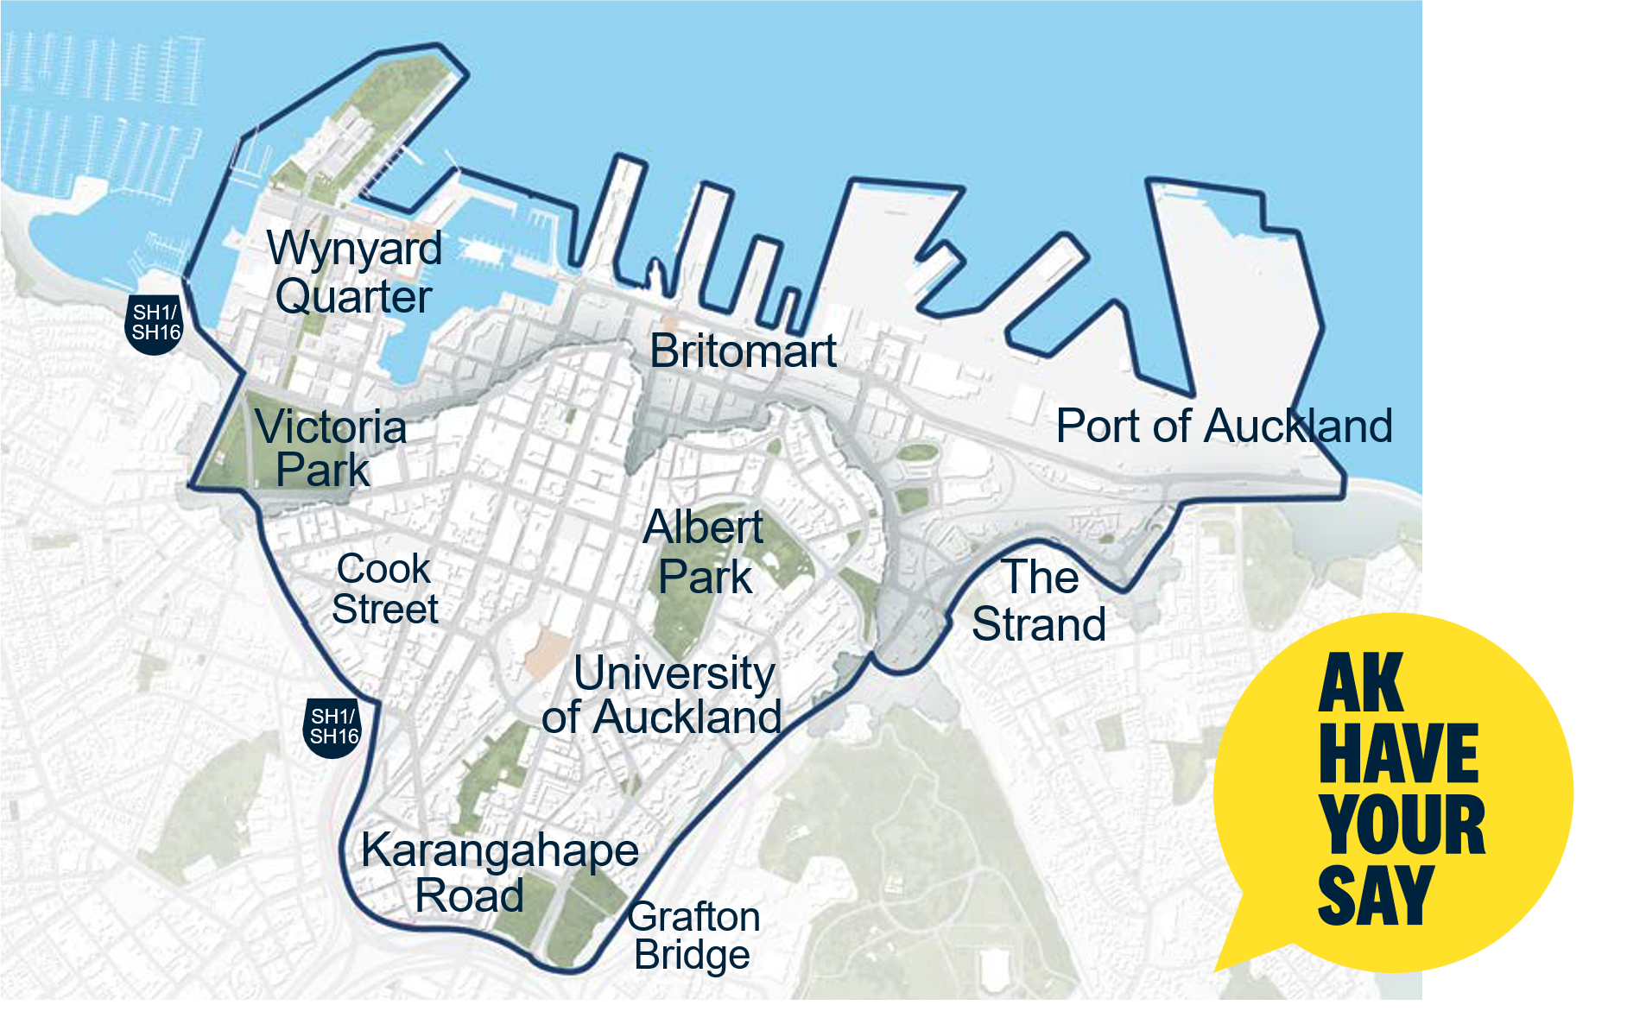
Transcriber's Note: The map on the previous page shows the central Auckland area outlined with a thick dark boundary, indicating a consultation or feedback area.
The highlighted area includes the waterfront and central city, with wharves extending into the harbour.
Key labelled locations within or near the boundary include: Wynyard Quarter, Victoria Park, Britomart, Port of Auckland, The Strand, Albert Park, University of Auckland, Cook Street, and Grafton Bridge.
Several road markers appear along the boundary, indicating major routes.
On the right side of the image is a yellow speech bubble containing the text: "AK HAVE YOUR SAY."
The map appears to invite public feedback about the outlined central Auckland area.

Question 6: City centre
Auckland's City Centre is the economic heart of our region. Overall, the city centre accounts for about a fifth of everything produced in Auckland's economy.
We want to make public spaces work better for people, get more value from major investments in transport, and make sure council helps the city centre thrive as a place to live, work, study, and visit.
What improvements do you think we should prioritise in the city centre? (Select up to 4)
☐ Better connections—improve links between the city centre, the waterfront and nearby neighbourhoods.
☐ Events and city life—attract people to the city centre through events, culture and a strong sense of place.
☐ Getting around—make it easier to walk, drive, cycle and use public transport in the city centre and from east to west, including better traffic flow.
☐ Māori identity and culture—reflect and celebrate Māori identity and culture throughout the city centre.
☐ Safety—a safer and more welcoming city centre, both day and night, for residents, workers and visitors.
☐ Streets and public spaces—improve streets, parks and public spaces so the city centre is a great place to live and spend time in.
☐ Supporting businesses—help businesses succeed by making them easier to access and attract more visitors to the city with well-designed streets and public spaces.
☐ Other (please specify): _________________________
Have more to say? You can attach extra pages.
End of How to have your say

