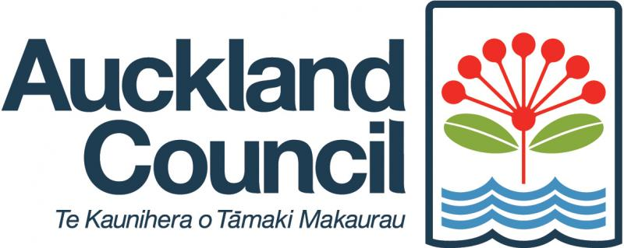
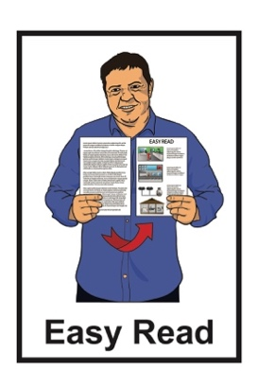

Long-term Plan
2024 to 2034:
Tell us what you think
Published: February 2024

About this document

This is an Easy Read document from Auckland Council about their
Long-term Plan 2024 to 2034.

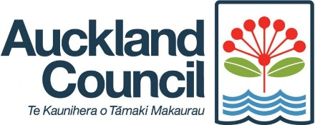
In this Easy Read document the words we / our means Auckland Council.

Long-term means over a long time.

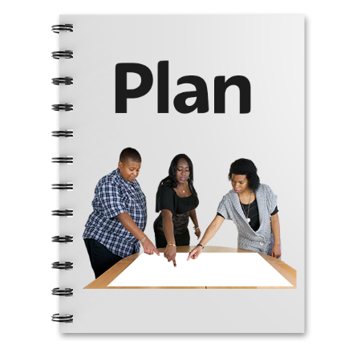
The Long-term Plan 2024 to 2034
is about how we:
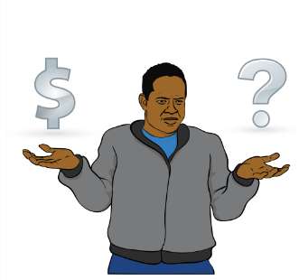
want to make Auckland better over the next 10 years
will look after the money to make sure we do this.
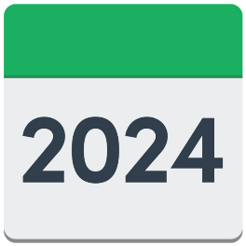
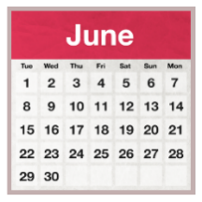
The new long-term plan will start in June 2024.

Before we decide what to do we want to know what you think about our long-term plan ideas.

On page 14 you can find information on how you can tell us what you think of our long-term plan ideas.

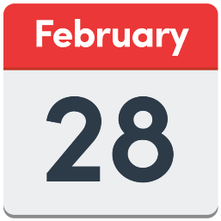
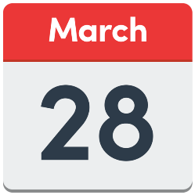
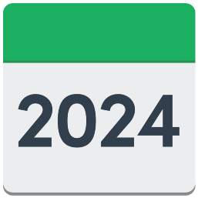
You can tell us what you think between:
28 February 2024
to
28 March 2024.

About our central proposal

Our central proposal is what we think is the best long-term plan for the next 10 years.

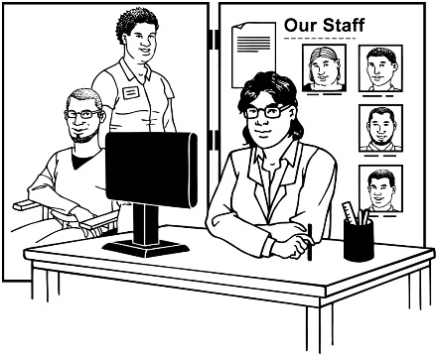
The main points of our central proposal are:
keeping important activities / services going without using more money
spending money where it is needed the most.

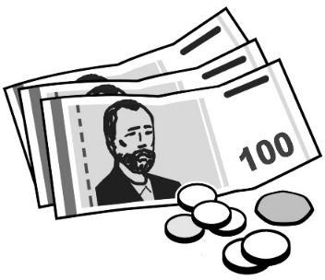
Our central proposal includes using about 40 billion dollars as capital investment.

Capital investment means buying things which will support Auckland Council to be better.
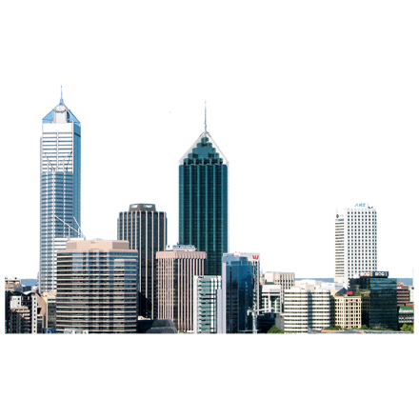

This includes things like:
buildings
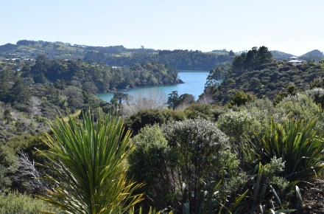
land
- machinery.

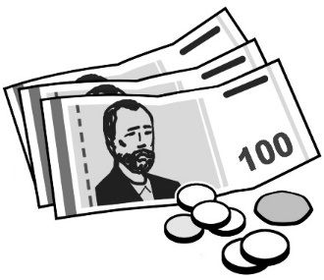
Our central proposal also includes using about 70 billion dollars for things like:
making public transport
- faster
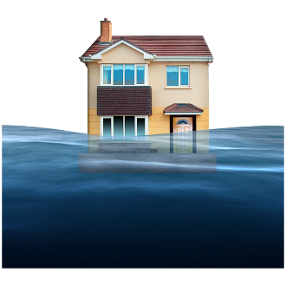
- easier to use
making Auckland stronger against flooding.

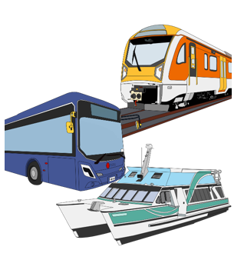
Public transport is the ways travel around Auckland that anyone can use like:
buses
trains
ferries.

How we are going to pay for this

Our central proposal includes people paying higher rates.

Rates is the money you pay to your Council.

Councils use the money from rates to pay for lots of things things like:
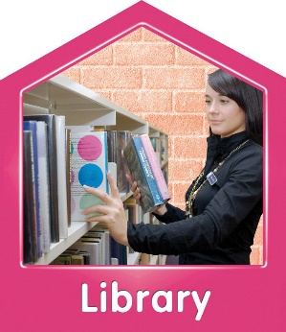
      - water pipes / systems
      - roading / footpaths
      - libraries
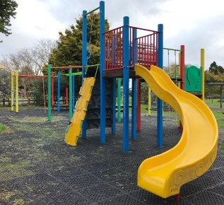
      - parks / playgrounds
      - sports grounds.

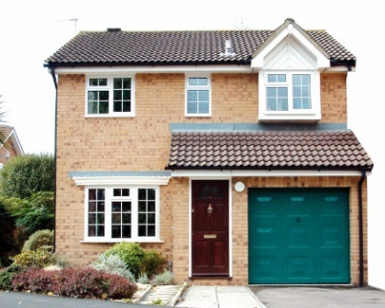
If you own your home the amount of rates you pay is worked out based on what your property is worth.

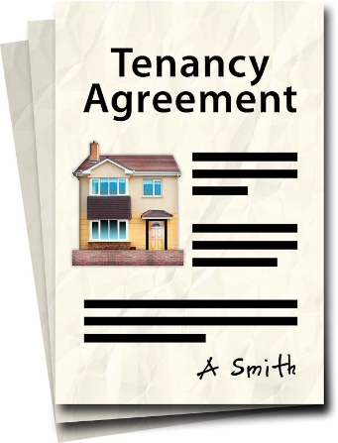
If you rent a house your landlord may use some of your rent money towards the rates they pay.

This means if rates go up then your rent costs may go up too.

Rates will go up by:
about 8 percent in year 1
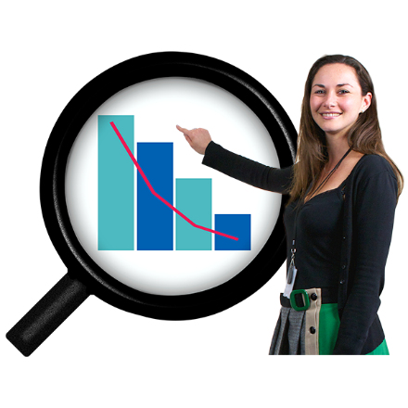
about 4 percent in year 2
about 8 percent in year 3
about 2 percent above inflation each year after that.

Inflation is how much the cost of things goes up every year.
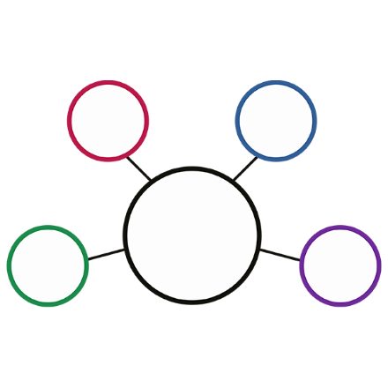

We could pay for all the
activities / services we propose in different ways.
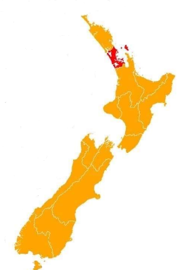

One way is by making an Auckland Future Fund.

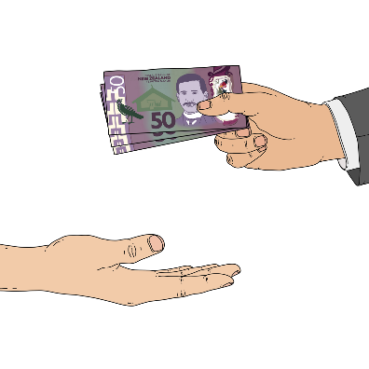
The Auckland Future Fund is money that would be kept to use in time / years to come in Auckland.

If we set up an Auckland Future Fund we would not need to use money from rates as much as we do now.

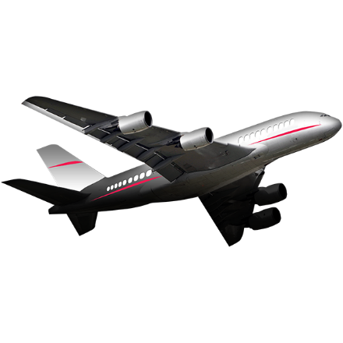
All the parts of Auckland Airport that Auckland Council owns would likely be sold over time to add money to the Auckland Future Fund.

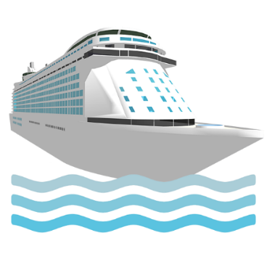
Another way we would add money to the Auckland Future Fund is to lease the Port of Auckland.

Leasing is when people pay to use things.

Here this would be things the Auckland Council owns like:
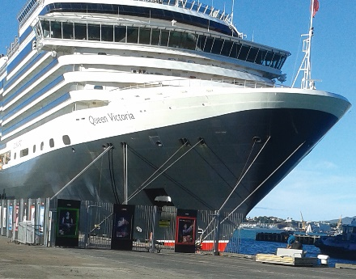
land
docks / wharves
equipment.

Other ideas

There are other ideas for our
long-term plan.

We could:
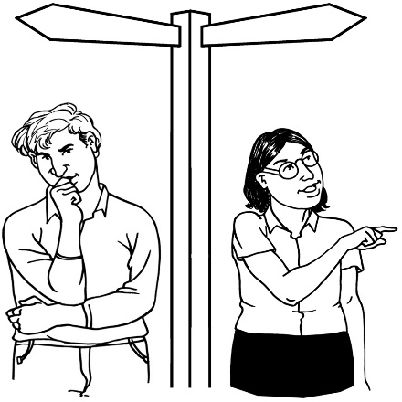
do less than what we are suggesting in our central proposal
do more than what we are suggesting in our central proposal.

Doing less

Doing less would mean:
we spend less money now
rates do not have to go up as high
we have lower debt levels.
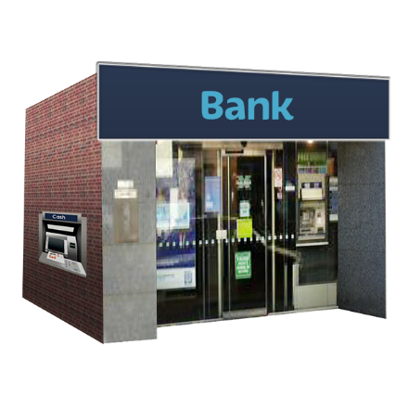

Debt is how much money we would have to give back to where we borrowed it from like the bank.

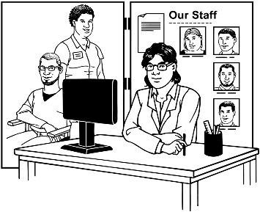
Spending less money now means:
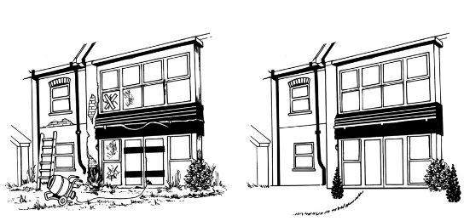
stopping some
activities / services
slowing down on starting anything new.
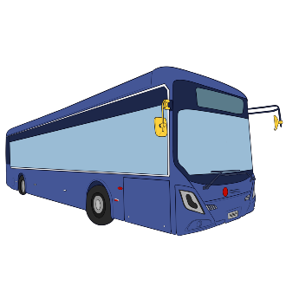
Spending less money now would look like:
less bus services
no money being spent on big events
no money being spent on making Auckland stronger against flooding
less money being spent on things like:
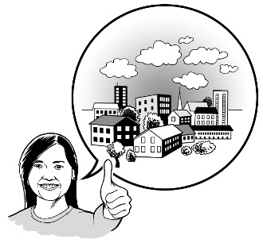
- community development – making communities better
- public art.
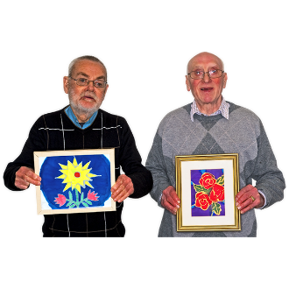

Public art is art that everyone can see in places like parks.

Doing more

Doing more would mean:
spending more money now
spending more money on transport services like buses
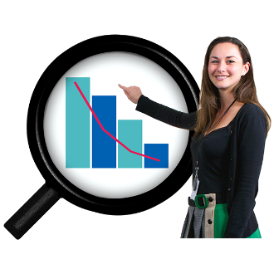
rates going up higher than what we have said in our central proposal
more debt
more events
better funding for local boards.

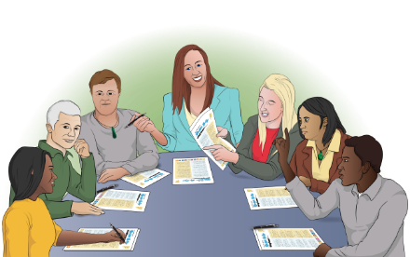
Local boards are groups of people who work within the Auckland Council for different communities / areas around Auckland.

How to tell us what you think

To let us know what you think about our long-term plan you can:
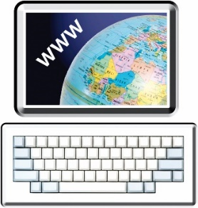
go to this website:
akhaveyoursay.nz/ourplan
phone:
09 301 0101
visit your local:
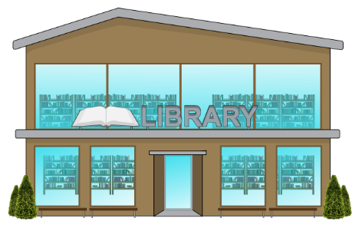
- library
- service centre.

You can tell us what you think between:
28 February 2024
to
28 March 2024.

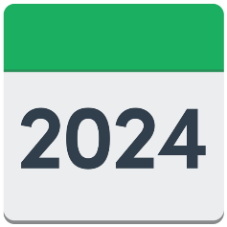
Decisions on the long term plan will be made in June 2024.

We will put the long-term plan information on our website:
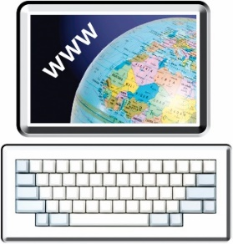
akhaveyoursay.nz/ourplan
This information has been written by Auckland Council.

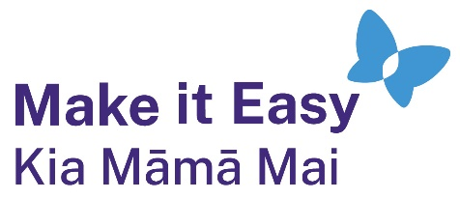
It has been translated into Easy Read by the Make it Easy Kia Māmā Mai service of People First New Zealand Ngā Tāngata Tuatahi.
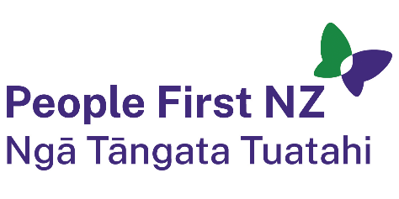
The ideas in this document are not the ideas of People First New Zealand Ngā Tāngata Tuatahi.
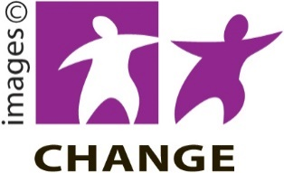
Make it Easy uses images from:

- Changepeople.org

            - Photosymbols.com
- SGC Image Works
- Huriana Kopeke-Te Aho
- T. Wood.
All images used in this Easy Read document are subject to copyright rules and cannot be used without permission.

